Maple Armor

FW151-FP
Fire Telephone System

Installation, Programming and Operation Manual

DOC-FW151-FP-UM-R1.0
Table of Contents
1. Fire Telephone System Limitations VIII
2. Agency Listings, Approvals IX
2.1 Underwriters Laboratories (UL/ULC) IX
2.1.1 Requirements for All Installations IX
2.2 FW151-FP DCP X
2.3 Board Assembly Diagram XI
2.4 FW151-FP Configuration XII
2.5 Specifications and Features XII
2.6 System Components XIII
2.6.1 Components Overview XIII
2.6.2 Master Audio Panel (MAP) XIV
2.6.3 Zone Selector (ZS) XVI
2.6.4 Main Motherboard (MB) XVII
2.6.5 Display and Keypad Board (DK) XVIII
2.6.6 Zone Selector (ZS) Board XIX
2.6.7 Telephone Board Slot (TBS) XX
2.6.8 Telephone Board (TB) XXI
2.6.9 Power Supply (PS) XXII
2.6.10 Batteries Set (BATT) XXIV
3. Installation XXV
3.1 Cautions XXV
3.2 DCP Location XXV
3.3 DCP Installation Notice XXV
3.4 DCP Mounting Space XXVI
3.5 DCP Installation Size XXVIII
3.6 Cabinet Mounting XXVIII
3.7 Remove Knock-Outs XXIX
3.8 Battery Installation XXIX
3.9 Module Address Setting XXX
4. System Wiring XXXI
4.1 Wiring Notes XXXI
4.2 Power Limiting XXXI
4.2.1 Wiring Entering the Enclosure XXXI
4.2.2 Electrical Separation XXXII
4.3 Power Supply Wiring XXXII
4.3.1 AC Connection - Supervised XXXII
4.3.2 Battery Connection - Supervised XXXV
4.4 Addressable Fire Fighter’s Telephone Circuit Wiring - Supervised XXXVI
4.4.1 Addressable Fire Fighter’s Telephone Circuit Wiring – Class A/DCLA XXXVI
4.4.2 Addressable Fire Fighter’s Telephone Circuit Wiring – Class B/DCLB XXXVIII
4.5 Communication Port Connection - Unsupervised XXXIX
4.6 System Checkout XL
4.6.1 Before Turning the Power On XL
4.6.2 Power-up Procedure XL
4.7 Troubleshooting XL
4.7.1 Circuit Trouble XL
4.7.2 Ground Fault XLI
4.7.3 Battery Trouble XLI
4.7.4 Common Trouble XLI
5. Functions XLII
5.1 Interface Functions XLII
5.1.1 Archive XLII
5.1.2 Query XLIII
5.1.3 Login XLIV
5.2 Display, Buzzer and Button Functions L
5.2.1 Liquid Crystal Display (LCD) L
5.2.2 LED Indicators L
5.2.3 Buzzer LI
5.2.4 Buttons LII
5.2.5 ZS Keypad LIII
5.3 Operation LIV
5.3.1 Answer and Hangup LIV
5.4 Status Handling LIV
5.4.1 Standby Condition LIV
5.4.3 Trouble Conditions LIV
5.5 Event History LV
5.6 Configuration and Maintenance LVI
5.6.1 PC Configuration LVI
5.6.2 Fire Telephone System Access Control LVI
5.6.3 Battery Maintenance LVII
6. Programming LVIII
6.1 Project Management LVIII
6.1.1 Create New Project LVIII
6.1.2 Delete Project LIX
6.1.3 Import Project File LIX
6.1.4 Close Project LX
6.1.5 Project Backup LX
6.1.6 Project Configuration Download LXI
6.2 Device Management and Configuration LXI
6.2.1 Device Adding and Configuration LXI
6.3 Delete Device LXVIII
6.4 FFT Zone Management LXIX
6.4.1 FFT Zone Adding LXIX
6.4.2 Delete FFT Zone LXX
6.4.3 FFT Zone Configuration LXX
6.5 Mapping Management LXXII
6.5.1 Mapping Adding LXXII
6.5.2 Delete Mapping LXXIII
6.5.3 Mapping Configuration LXXIII
6.5.4 Mapping Parameters Configuration LXXIV
6.6 Quick Configuration LXXVI
6.6.1 Project Configuration LXXVI
6.6.2 Project Download LXXVI
7. Appendix-A: Compatible Devices LXXVII
7.1 FFT Devices LXXVII
8. Appendix-B: Wire Selection Guide LXXVIII
8.1 FFT Bus Wire Selection Guide LXXVIII
9. Appendix-C: FW151-FP Power Consumption Calculations LXXIX
10. Appendix-D: Battery Calculations LXXX
10.1 Total System Current Calculations LXXX
10.2 Battery Capacity LXXXI
11. Appendix-E: Glossary and Acronyms LXXXII

List of Figures
Figure 1 FW151-FP Fire Telephone System X
Figure 2 FW151-FP Assembly Diagram XI
Figure 3 FW151-FP Assembly Diagram (Inside) XI
Figure 4 Master Audio Panel XIV
Figure 5 Zone Selector XVI
Figure 6 Mother Board & Daughter Board XVII
Figure 7 Display and Keypad Board XVIII
Figure 8 Zone Selector Board XIX
Figure 9 Telephone Board Slot XX
Figure 10 Telephone Board XXI
Figure 11 Fire Fighter Telephone Series XXI
Figure 12 Power Supply XXII
Figure 13 Input Voltage Selection Switch XXII
Figure 14 Input Voltage Connection Terminals and Fuse Location XXIII
Figure 15 Battery Port, CAN BUS, 24 VDC XXIII
Figure 16 Battery XXIV
Figure 17 DCP Surface-Mounted XXVI
Figure 18 DCP Flush-Mounted XXVII
Figure 19 DCP Installation Size XXVIII
Figure 20 DCP Electrical Separation XXIX
Figure 21 FW151-FP Battery Installation XXX
Figure 22 Module Address Switch XXX
Figure 23 AC Power Supply Wiring XXXII
Figure 24 Ground Wiring XXXIII
Figure 25 AC Power Supply Wiring (Terminal) XXXIV
Figure 26 Power Supply Wiring XXXIV
Figure 27 Battery Connection XXXV
Figure 28 Class A/DCLA Wirings of FW151-FP and TES/TWJ XXXVI
Figure 29 Class A/DCLA Wirings of TES and TWJ XXXVII
Figure 30 Class A/DCLA Wirings of TES/TWJ XXXVIII
Figure 31 Addressable FFT BUS Circuit Wirings – Class B/DCLB XXXVIII
Figure 32 Addressable FFT BUS Circuit Wirings – Class B/DCLB XXXIX
Figure 33 Programming using the Motherboard (MB) Rj45 XL
Figure LCD1 XLII
Figure LCD2 XLII
Figure LCD3 XLIII
Figure LCD4 XLIII
Figure LCD5 XLIII
Figure LCD6 XLIV
Figure LCD7 XLIV
Figure LCD8 XLIV
Figure LCD9 XLV
Figure LCD10 XLV
Figure LCD11 XLV
Figure LCD12 XLVI
Figure LCD13 XLVI
Figure LCD14 XLVI
Figure LCD15 XLVII
Figure LCD16 XLVII
Figure LCD17 XLVII
Figure LCD18 XLVIII
Figure LCD19 XLVIII
Figure LCD20 XLVIII
Figure LCD21 XLIX
Figure LCD22 XLIX
Figure LCD23 L
Figure ZS LIII
Figure EDCS1 LVIII
Figure EDCS2 LVIII
Figure EDCS3 LIX
Figure EDCS4 LIX
Figure EDCS5 LX
Figure EDCS6 LX
Figure EDCS7 LXI
Figure EDCS8 LXII
Figure EDCS9 LXIII
Figure EDCS10 LXIV
Figure EDCS11 LXIV
Figure EDCS12 LXV
Figure EDCS13 LXV
Figure EDCS14 LXVI
Figure EDCS15 LXVII
Figure EDCS16 LXVII
Figure EDCS17 LXVIII
Figure EDCS18 LXVIII
Figure EDCS19 LXIX
Figure EDCS20 LXX
Figure EDCS21 LXX
Figure EDCS22 LXXI
Figure EDCS23 LXXI
Figure EDCS24 LXXII
Figure EDCS25 LXXIII
Figure EDCS26 LXXIII
Figure EDCS27 LXXIV
Figure EDCS28 LXXIV
Figure EDCS29 LXXV
Figure EDCS30 LXXV

List of Tables
Table 1 Authority Having Jurisdiction(AHJ) IX
Table 2 FW151-FP Module XII
Table 3 FW151-FP DCP Specifications XII
Table 4 System Components XIII
Table 5 MB Terminal Connection Parameter Description XVII
Table 6 DK Terminal Connection Parameter Description XVIII
Table 7 ZS Terminal Connection Parameter Description XIX
Table 8 TBS Terminal Connection Parameter Description XX
Table 9 TB Terminal Connection Parameter Description XXI
Table 10 PS LED Definition XXII
Table 11 PS AC Terminal Definition XXIII
Table 12 PS DC Terminal Definition XXIII
Table 13 Battery Space XXIX
Table 14 Module Address Range XXX
Table 15 Circuit Trouble XLI
Table 16 LED Operation on the main audio panel L
Table 17 Button Functions LII
Table 18 Trouble Event LV
Table 19 Addressable FFT BUS Wiring LXXVIII
Table 20 Maximum Number of PCBA LXXIX
Table 21 System Current Calculation LXXX
Table 22 Battery Calculation LXXXI

1. Fire Telephone System Limitations
The FW151-FP is a Fire Telephone System designed for integrated amplifiers and telephones. When the Fire Telephone System is only used for fire telephones without amplifiers, may not be in normal working condition if it without being connected to compatible fire telephone equipment (telephone stations,telephone wall jacks, etc.). The wiring used for interconnection also must be size up properly, in order to carry the total current for the corresponding electrical appliances without excessive voltage drop. Please refer to Appendix-B: Wire Selection Guide for details.

The DCP must be connected to a dedicated primary electrical source that has a high degree of reliability and adequate capacity for this panel. Power supply is a core component. Do not use power supply from other vendors. The means of disconnecting the power supply shall be available only to authorized personnel. Turn off the power supply before disconnecting it from the panel. Do not touch any part of the power supply when the power is on. Power supply needs to be marked clearly with "High voltage inside. Do not touch.".

A battery set (24V) that has enough capacity to properly operate the system with 24 hours standby as per UL 864 in the 10th Edition (section 69.2.3 and 69.2.5)/ULC-S527 in the 4th Edition (section 10.5) or as otherwise required by local codes. These batteries will lose capacity as they are aging. Batteries must be replaced either when they fail to provide the panel with the required power for standby, or the battery life reaches to 4 years. These batteries must be checked for its performance at least twice a year to comply with the local codes if required.

Even though this DCP was built to last for the expected life of the voice system, parts can fail at any time. Therefore, a regular test and inspection schedule should be followed and documented to make sure each part of the system has been tested, as indicated in Chapter 7 of NFPA 72, and UL-864, CAN/ULC-S536 or more often if required by local code. Malfunctioning units must be replaced or repaired immediately by factory’s authorized service personnel.

This DCP is designed to select whether or not to receive communications when the telephone devices connected to it initiate a call under specific conditions. These conditions may or may not represent a life-threatening condition. Therefore, it is important that the building owner, manager, or representative promulgate, distribute, and/or post instructions describing steps to be taken when the DCP receives communiciate signals from fire telephone devices. These instructions should be developed in co-operation with representatives of the local authority having jurisdiction and in accordance with the applicable standards.

2. Agency Listings, Approvals

2.1 Underwriters Laboratories (UL/ULC)

2.1.1 Requirements for All Installations
The general requirements are described in this section. When an individual device is installed, the specific section of the manual for additional requirements should be referred to.
1. All field wiring must be installed in accordance with NFPA 72 National Electric Code, CSA C22.1 Canadian Electrical Code Part 1, CAN/ULC-S524, NBC, NFC, AHJ, and local codes.
2. Full system verification must be performed whenever the panel is programmed or the database is updated.
NOTICE TO USERS, INSTALLERS, AUTHORITIES HAVING JURISDICTION, AND OTHER INVOLVED PARTIES
This product incorporates field-programmable software. In order for the product to comply with the requirements in the Standard for Control Units and Accessories for Fire Alarm Systems, UL 864 and CAN/ULC-S527, certain programming features or options must be limited to specific values or not used. at all as indicated below.

Program feature or option | Permitted in UL 864? (Y/N) | Permitted in S527? (Y/N) | Possible Settings | Settings permitted in UL 864 | Settings permitted in S527
Auto Silence on FACP (FW106) | Y | Y | Enabled, Disabled | Disabled | Disabled

Table 1 Authority Having Jurisdiction(AHJ)

2.2 FW151-FP DCP
The DCP is an intelligent emergency voice system designed for small and medium-size facilities. The DCP is ideally suited for both new and retrofit installation in commercial, institutional, and industrial applications.
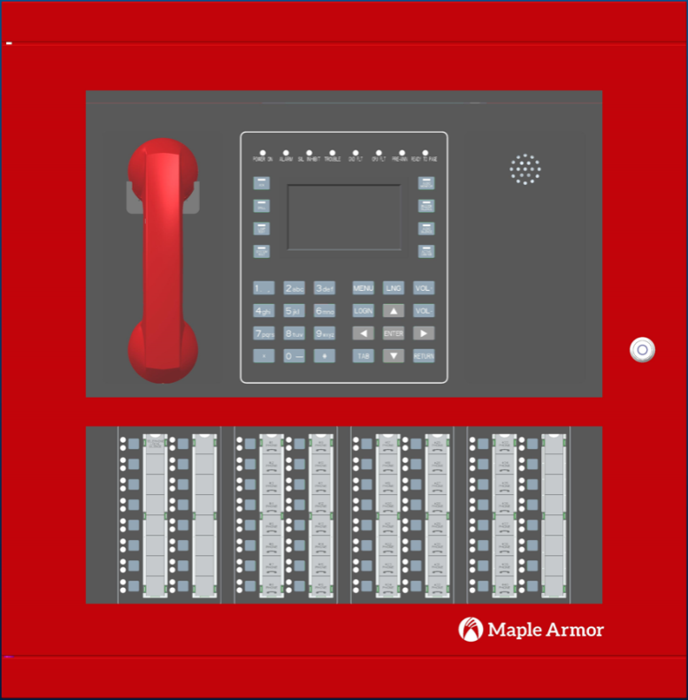
Figure 1 FW151-FP Fire Telephone System

- The FW151-FP DCP is a communication system that meets the requirements of UL 864 in the 10th Edition and CAN/ULC-S527 in the 4th edition. It can support:
- 4.3” full color TFT LCD
- Up to 64 zone selector buttons and 128 zone indicators per DCP
- Indication of all required fault conditions
- Master telephone handset can be monitored by panel. For example, a trouble signal will be reported for an open circuit
- Class B(DCLB) or Class A(DCLA) addressable firefighter telephone loop supporting up to 40 addressable telephone stations (FW863) or 40 addressable telephone wall jacks (FW864A). Additional 4 non-addressable telephone wall jacks (FW864) may be connected to each addressable telephone wall jacks (FW864A) and are intended to be installed in the same zone.
- Modular PCBA for ease of installation and maintenance
- Digitized voice capability
- Full power supply and battery supervision capability
- Operate from 24 VDC backup batteries in the event of a master power failure
- Front door opening 180 degrees

2.3 Board Assembly Diagram
The FW151-FP provides modular assembly. The assembly diagram is shown in Figure 2 and Figure 3 as below.
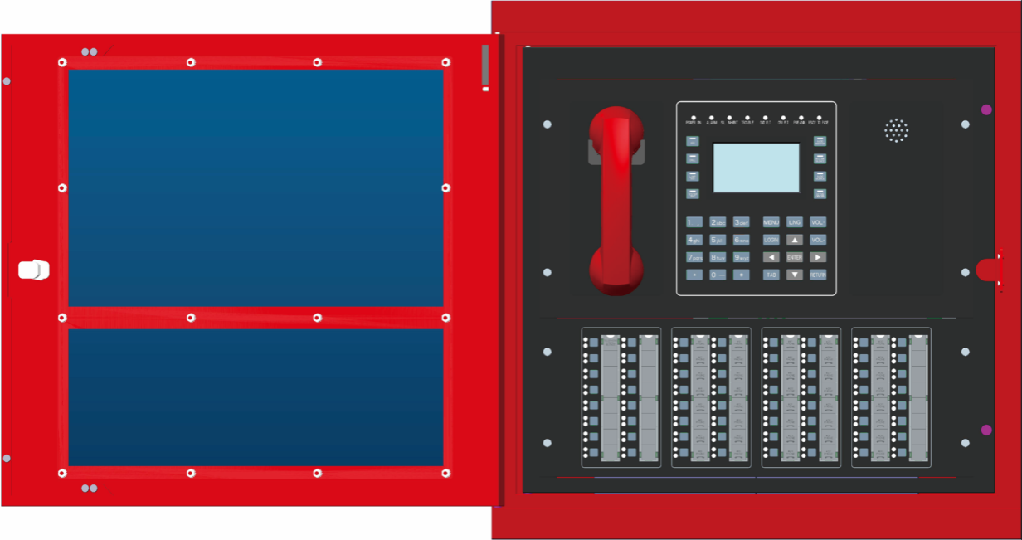
Figure 2 FW151-FP Assembly Diagram

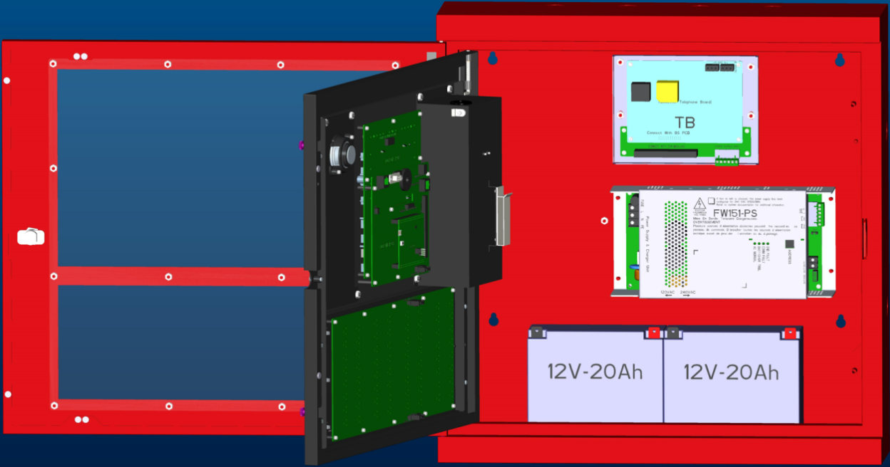
Figure 3 FW151-FP Assembly Diagram (Inside)

Note: Refer to Table 1 for the module’s brief introduction.

2.4 FW151-FP Configuration
The FW151-FP consists of modules with different functions. All the functional modules are shown in Table 2:
Table 2 FW151-FP Module
Module | Qty. | Fixed/  Configurable | Notes
FW151-MB | 1 | Fixed | Mother board, LCD, LED, buzzer, audio sources, etc.
FW151-DB | 1 | Fixed | Core CPU board, flash
FW151-DK | 1 | Fixed | Keypad, LED indicators, buzzer, supervised core CPU on daughter board
FW151-ZS | 1 | Configurable | Zone selector, used for fire fighter telephone selection, special function selection or indication etc.
FW151-TBS | 1 | Fixed | PCBA slots for various modules
FW151-TB | 1 | Configurable | One telephone board only supports one telephone circuit (1 Class A/DCLA or 2 Class B/DCLB), up to 40 addressable TWJs/TESs and maximum of 160 TWCs
FW151-PS | 1 | Configurable | Power supply, AC 120V or AC 240V input, DC 20.4V–DC 27V output
BATT | 2 | Configurable | 2*12V battery

2.5 Specifications and Features
The specifications and features of the FW151-FP DCP are described in Table 3:
Table 3 FW151-FP DCP Specifications
General | Based on digital dual-core CPU processor design, fully configurable on master panel with password protection
Environmental | - Operating Temperature: 32°F–120°F (0°C -49°C)  - Relative Humidity: Up to 93% @ 90°F (32°C)  - To be installed in normal dry indoor environment only
Primary Power Supply | - Input: 110–120 VAC 60 Hz (6 Amps), or 220–240 VAC 50 Hz (3.5 Amps)  - Output: 24 VDC–27 VDC, supply for:  - FW151-MB  - FW151-DB  - FW151-DK  - FW151-ZS  - FW151-TBS  - FW151-TB  - TES  - TWJ  - TWC  - BATT
Secondary Power Supply | - 24 VDC (2x 12Vdc batteries in series)  - Max. Battery Size: 20AH  - Max. Charging Current: 2.54 A
Addressable Telephone Loop Circuit | - Maximum Current (short): 0.4A  - Class A or DCLA - DCLB or Class B circuit  - Supports a maximum of 40 addresses for TWJ and/or TES  - Output Voltage: 27V  - Maximum Normal Standby Current: 169mA  - Maximum Talking Current: 275mA  - Max Line Capacitance: 0.3 uF  - Max Line Resistance: 42.8 Ohm  - End-of-Line Resistor: 3.9 KΩ (for TES or TWJ) or 22 KΩ (for TWC)

2.6 System Components

2.6.1 Components Overview
FW151-FP components description is shown in Table 4.
Table 4 System Components
Module | Description | FW151-FP Components
MAP | Master audio panel contains mother board, daughter board, DK (LCD display, LED indicators, buzzer, keypad, master handset and local speaker) | √
ZS | Zone selector | √
TBS | Board slots | √
TB | Telephone board | √
PS | Power-supply and charger unit | √
BATT | Battery sets | √

2.6.2 Master Audio Panel (MAP)
The MAP is the main control unit of FW151-FP DCP, which integrates the CPU board, a full color 4.3” LCD, 8 LEDs for signal status, 8 LEDs for system status, 8 functional buttons, 24 buttons logical input keypad, 1 buzzer and 1 master microphone. The cords for the master telephone handset is 2 meters in length.
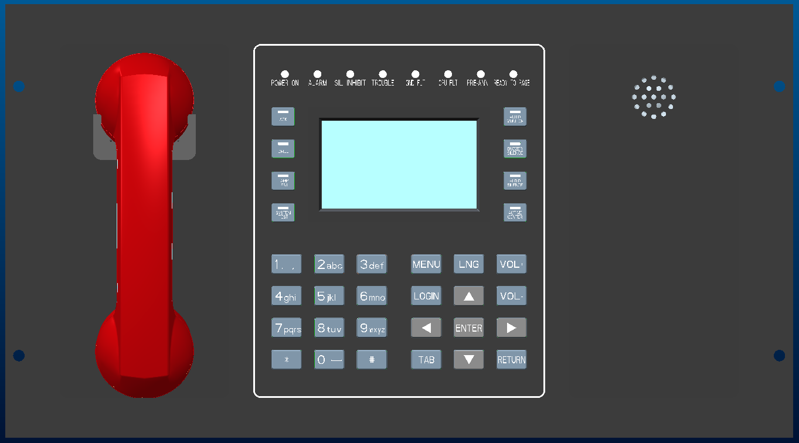

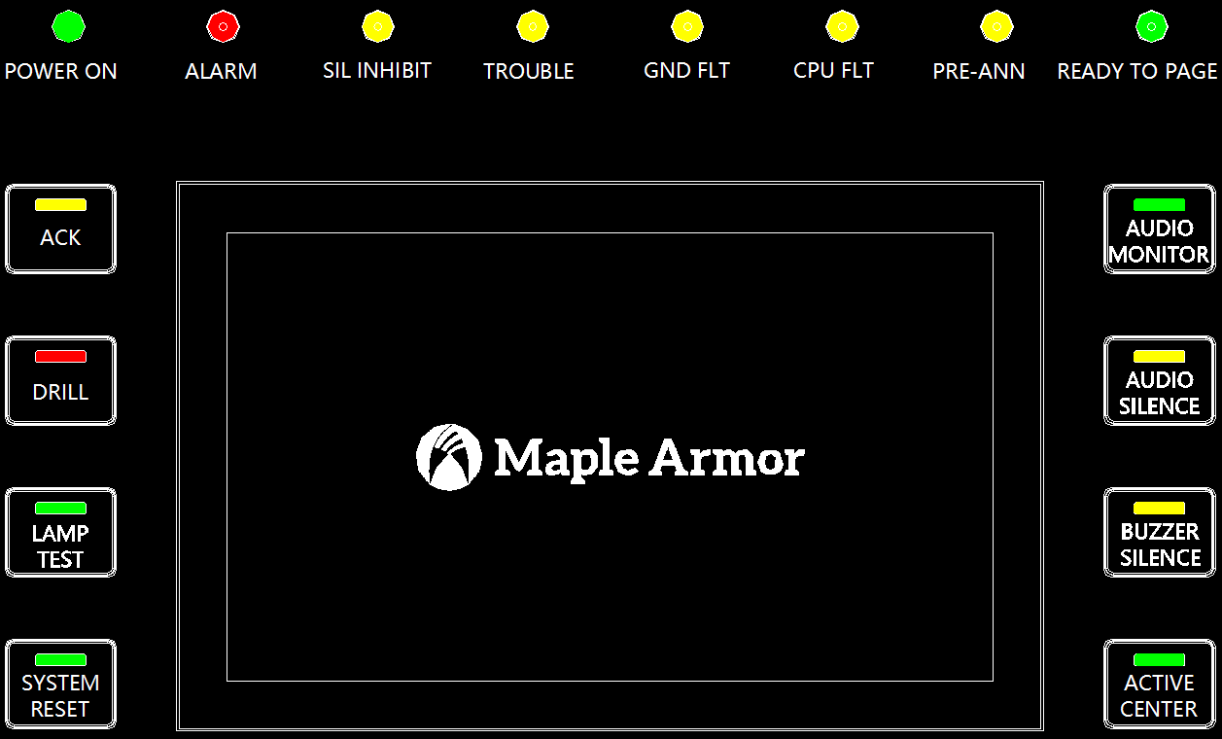
Figure 4 Master Audio Panel

Independent LED indicator (Total 8)
- POWER ON Power operation indicator
- ALARM Fire alarm indicator (not available for fire telephone)
- SIL INHIBIT Silencing is disabled when DCP receives the first automatic alarm input (not
available for fire telephone)
- TROUBLE Trouble indicator (automatically lights up after receiving a trouble signal）
- GND FLT Ground fault indicator (external wiring short to chassis or ground）
- CPU FLT MCU fault indicator (master MCU or crystal oscillator stops working）
- PRE-ANN Indicative of the pre-announce tone status before microphone live paging (not
available for fire telephone)
- READY TO PAGE Microphone live paging status indicator (not available for fire telephone)

Button/LED Combination (Total 8)
- ACK （with LED） Acknowledge button (the LED lights up with unconfirmed information）
- DRILL （with LED） Fire drill test button (not available for fire telephone)
- LAMP TEST （with LED） Verify the colors of all LEDs
- SYSTEM RESET （with LED） Reset the system
- AUDIO MONITOR （with LED）Monitor whether the background music is playing from the local speaker
(not available for fire telephone)
- AUDIO SILENCE （with LED） Silence or resound the local speaker
- BUZZER SILENCE （with LED） Silence or resound the buzzer
- ACTIVE CENTER （with LED） Command center control switching (not available for now)

Definition of Digital Key and Functional Key
- 0-9, * and # Numerical and symbol buttons (Input for logic linkage programming）
- MENU Main menu shortcut button
- LNG Language selection button
- LOGIN Sign up or login shortcut button
- TAB Input or toggle between options
- RETURN Return to previous menu
- VOL+ Volume up button
- VOL- Volume down button
- 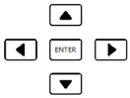 Up/down/left/right/enter navigation buttons

2.6.3 Zone Selector (ZS)
The zone selector panel integrates 64 functional buttons, 64 green-red double-color and 64 yellow single-color LED indicators, 8 label strips. It’s a core control device, usually used as a state indicator for working of the field circuits, or selective voice messages, activation/inactivation certain functions etc.
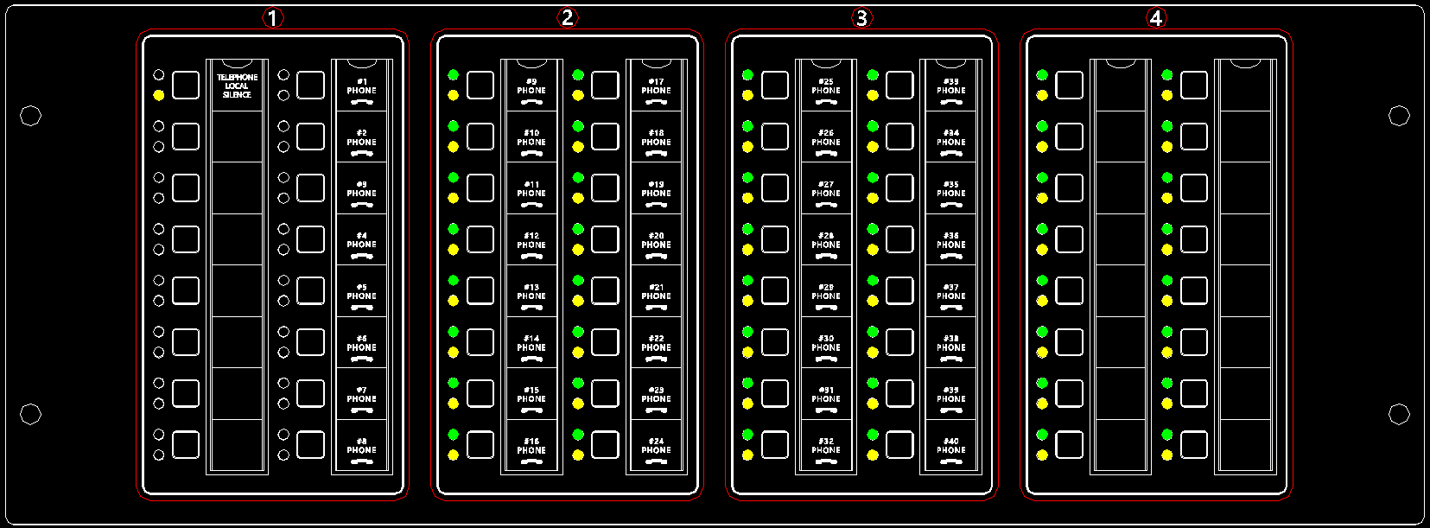
Figure 5 Zone Selector
2.6.3.1 Combination Function Button（Figure 5, Columns #1 ）
TELEPHONE LOCAL SILENCE | Silence the ringtone of local speaker when it receives calls from FFTs

2.6.3.2 External Telephone Access Button（Figure 5, Columns #2 to #5）
#1 PHONE – #40 PHONE | Press it to answer the call when it comes from FFT

- labels are available for handwriting, editing and printing by user
- Keys and LED indicators are left with the default factory settings, which can be configured according to the needs of the different applications by the EDCS Programming Tool

2.6.4 Main Motherboard (MB)
MB, the most core device in the DCP, is integrated with the whole voice system’s most control functions, including built-in 4-channel audio generator, 1 microphone port, 1 master telephone handset port, 1 DK, 2 ZSs, 1 RS232, 1 LCD, 1 Buzzer, 1 local speaker.
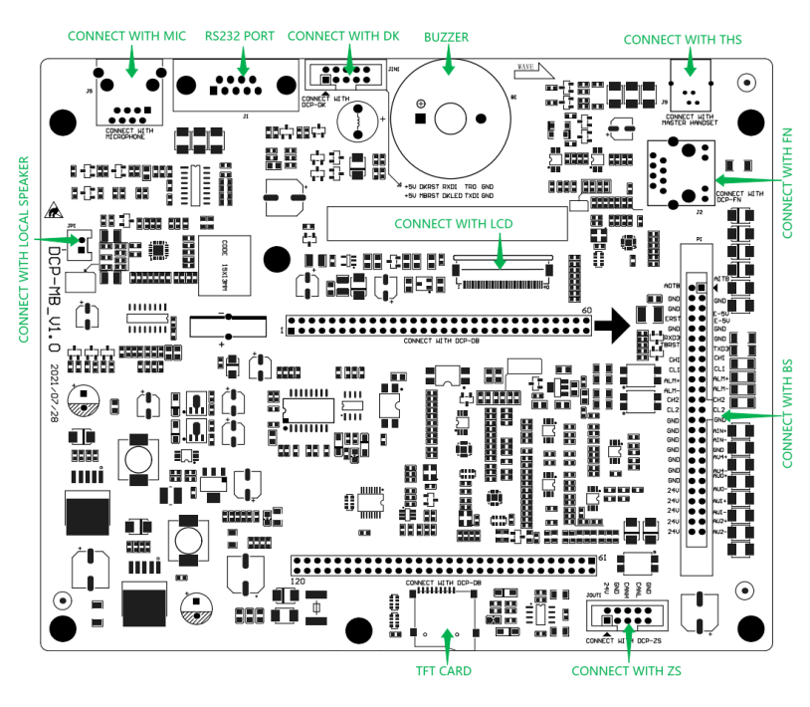
Figure 6 Mother Board & Daughter Board

- 50-pin IDE connector provides almost all control signals for the whole system. It contains evac, alert, paging, background music and bi-telephone audio signals which are related to the communication etc.
- In the normal standby, MB and DK can monitor each other's operating state, turn on a trouble sound and illuminate the CPU-FLT indicator.

Table 5 MB Terminal Connection Parameter Description
PCB Silk Screen | Terminal Function | Parameters
P1 | Signal input/output | 50 Pins, 2.54 mm, IDE flat cable
J5 | Master microphone input | RJ45, customized cable
J1 | RS232 | DB9 special cable
JIN1 | DK interface | 10 Pins, 2.54 mm, IDE flat cable
J9 | Telephone handset input | RJ11 telephone customized cable
J2 | Ethernet Port | Cat5 cable, Connect to PC
JOUT1 | ZS interface | 10 Pins, 2.54 mm, IDE flat cable
JP1 | Local Speaker | 2Pins, 2.54mm, Connect to the local speaker

2.6.5 Display and Keypad Board (DK)
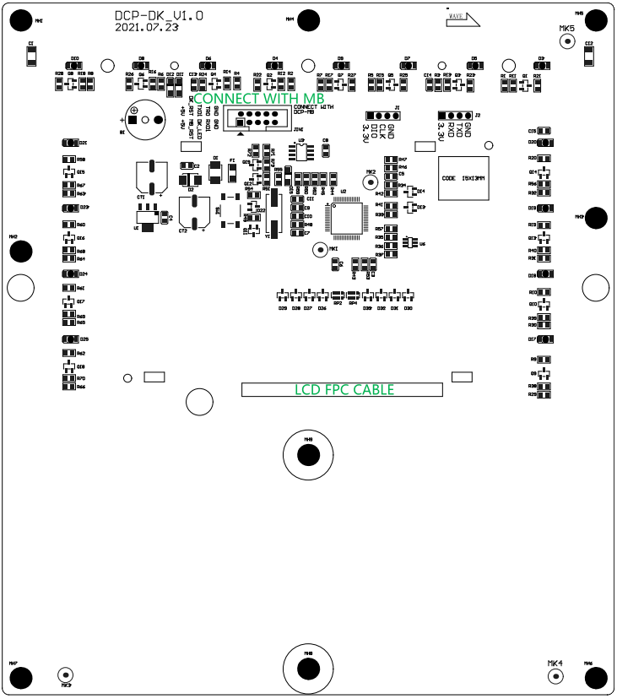
Figure 7 Display and Keypad Board

- DK is a main human-machine interface for the DCP.
- DK board is integrated with a keypad of 24 keys, 8 key combinations with LEDs and 8 independent status LED indicators.
- The state of the MB's core CPU is automatically monitored by DK and the core CPU fault is reported.

Table 6 DK Terminal Connection Parameter Description
PCB Silk Screen | Terminal Function | Parameters
JIN1 | Input/output | 10 Pins, 2.54 mm, IDE flat cables

2.6.6 Zone Selector (ZS) Board
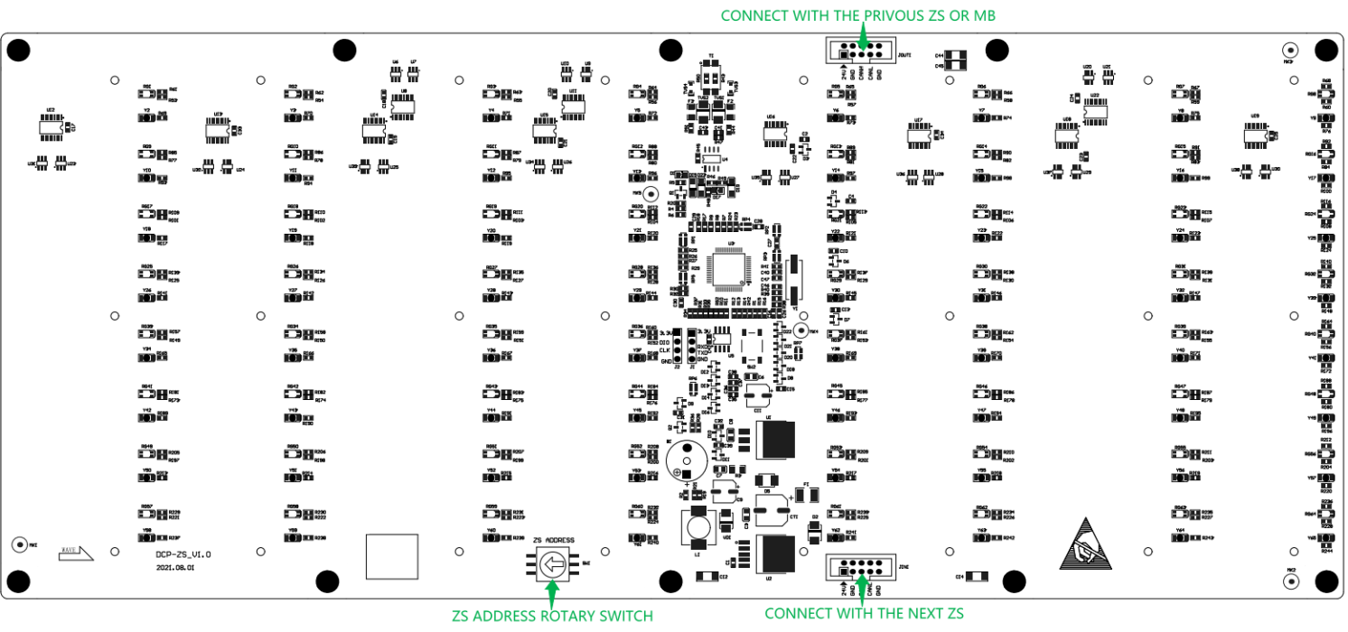
Figure 8 Zone Selector Board

- Each zone selector board is integrated with 64 buttons, and 64 yellow single-color & 64 red-green double-color LED indicators. They can be programmed to satisfy user-defined features by the EDCS Programming Tool.
- The zone selector board contains 2 terminal interfaces for 24 VDC & data signal input/output.
- Address must be set independently with the number selected only from 1 to 9.
- Any failed zone selector will result in a trouble signal on the MB.

Table 7 ZS Terminal Connection Parameter Description
PCB Silk Screen | Terminal Function | Parameters
JIN1 | Input | 10 Pins, 2.54 mm, IDE flat cables
JOUT1 | Output | 10 Pins, 2.54 mm, IDE flat cables
SW1 | Address selection | Address setting for ZS by selecting the number from 1–9

2.6.7 Telephone Board Slot (TBS)
The board slot is designed to connect with various PCBAs and aimed at the reduction of the electric wire connections inside the panel and the elimination of errors caused by the internal wiring.

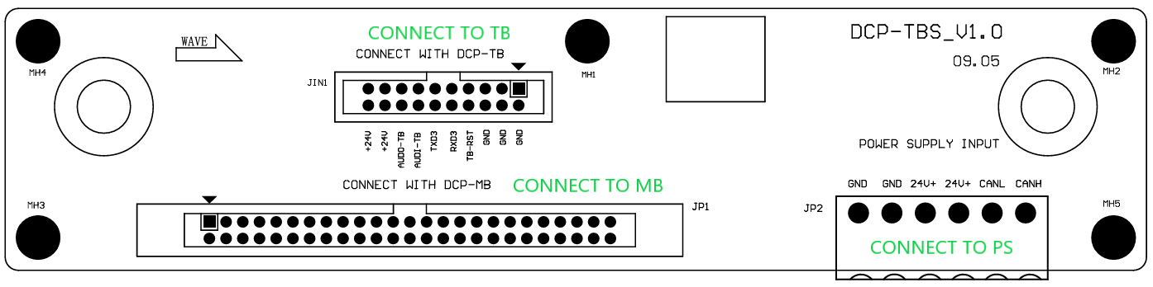
Figure 9 Telephone Board Slot

- An IDE 50 interface, 2 CAN buses, 1 serial UART data bus,, two-way telephone audio signals, and several reset signals, is used for the connection to the MB via 50-pin flat cables.
- One set of pin headers respectively used to connect to EC and TB circuits.
- 24 VDC power supply of a green terminal block with 6 pins.

Table 8 TBS Terminal Connection Parameter Description
PCB Silk Screen | Terminal Function | Parameters
JP1 | MB | 50 Pins 2.54 mm, IDE flat cables
JIN1 | TB | 20 Pins 2.54 mm (terminal-to-plug installation without wiring)
JP2 | POWER  INPUT | 6 Pins 5.08 mm, 6*12AWG (13A) flame retardant wire

2.6.8 Telephone Board (TB)
The telephone board (TB) module is used to connect the field telephone circuits (which may include: addressable TES telephone extension stations, addressable TWJ telephone wall jacks and TWC conventional wall jacks), and acts as a signal conversion between the master telephone and the remote telephones.
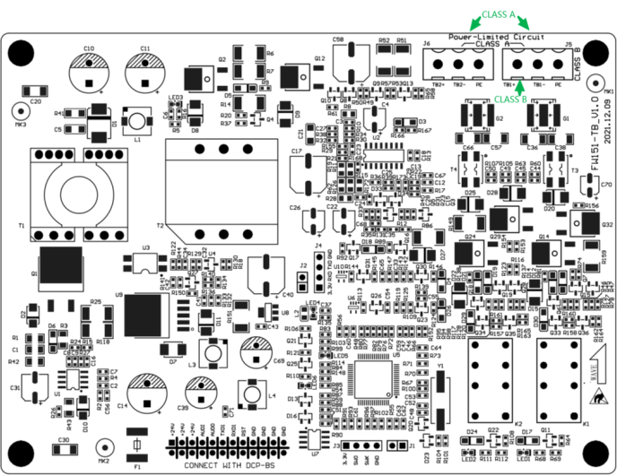
Figure 10 Telephone Board

- Provides one Class A(DCLA) or two Class B(DCLB) telephone circuits connection
- Supports one twisted pair communication. Length of cable can reach up to 1200 m
- Supports hybrid wiring for addressable telephone station and addressable telephone wall jacks. A maximum of 40 addressable devices
- Each addressable wall jack can connect to a maximum of 4 conventional wall jacks, that is, 40 addressable wall jacks can expand to include up to 160 conventional wall jacks
- Able to monitor external circuits for open or short-circuit conditions
- Telephone board wired to TWJ or TES (in three manners)

Table 9 TB Terminal Connection Parameter Description
PCB Silk Screen | Terminal Function | Parameters
J6 | Class A(DCLA) return | Connect to the fire fighter’s telephone, such as TES/TWJ
J5 | Class B(DCLB) or Class A(DCLA) out | Connect to the fire fighter’s telephone, such as TES/TWJ
FW863(TES) FW864A(TWJ) / FW864(TWC) FW451-W(THW)
Figure 11 Fire Fighter Telephone Series

2.6.9 Power Supply (PS)
Figure 12 Power Supply

Table 10 PS LED Definition
Silk Screen | LED Color | Definition
AC NORMAL | Green LED | AC Input normal
BATT/CHGR TRBL | Yellow LED | Battery fault or charger fault
COMM FAULT | Yellow LED | Internal CAN bus failure
GND FAULT | Yellow LED | Ground fault
ADDRESS | Rotary code switch | Power supply address (1-9)

- The picture of the input voltage selection switch is shown below. The switch is used to select 120 VAC input or AC 240 input. Local AC source voltage should be confirmed. Do not connect the FW151-FP panel to a 220 VAC source when this switch is set to 120V, or the power supply will be damaged.

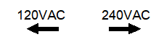
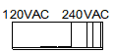
Figure 13 Input Voltage Selection Switch

- AC Input Port
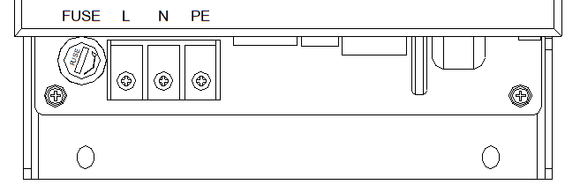
Figure 14 Input Voltage Connection Terminals and Fuse Location

Table 11 PS AC Terminal Definition
Port Name | PIN No. | Silk Screen | Definition
P1 | 1 | L | LIVE line (L)
P1 | 2 | N | NEUTRAL line (N)
P1 | 3 | PE | EARTH line (PE)

- Low Voltage Terminal
Figure 15 Battery Port, CAN BUS, 24 VDC

Table 12 PS DC Terminal Definition
Port Name | PIN | Signal Name | Definition
P4 | 1 | BATT+ | Battery positive pole
P4 | 2 | BATT- | Battery negative pole
P5 | 1 | 24V- | Power supply negative pole
P5 | 2 | 24V- | Power supply negative pole
P5 | 3 | 24V+ | Power supply positive pole
P5 | 4 | 24V+ | Power supply positive pole
P5 | 5 | CANL | Internal CAN L
P5 | 6 | CANH | Internal CAN H
SW2 | 1 | EN | Ground Fault Test
SW2 | 2 | DIS | Disable Ground Fault

Note: The power supply unit is an essential component. Do not use power supply units from other vendors. The external AC power must be turned off during the connection or the disconnection of the AC power cables to the panel. Do not touch any part of the power supply when the power is on.

2.6.10 Batteries Set (BATT)
- FW151-FP provides above 20 AH sealed lead-acid batteries to support up to 24 hours normal standby plus under the maximum loading that complies with the standard’s requirements.
- Batteries must be replaced either when they fail to provide the DCP with the required power for standby and telephone communication, or the battery life reaches 4 years.
- Refer to Battery Calculations for an appropriate battery capacity selection.

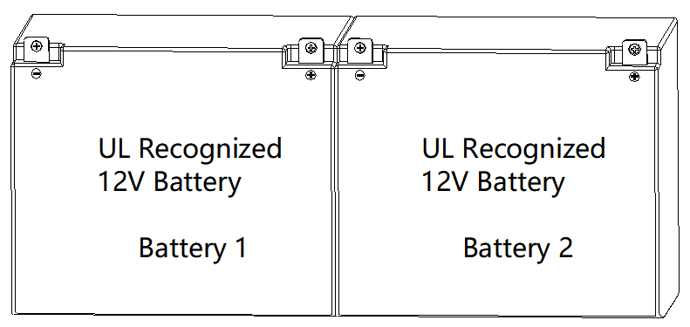
Figure 16 Battery

3. Installation

3.1 Cautions
3.1.1 Remove the PCB for any procedure that may cause dust, metal shavings, grease, or similar to come in contact with the board.
3.1.2 Disconnect all sources of power prior to installing or removing PCB modules, connecting or disconnecting wiring and programming jumpers.
3.1.3 Group the incoming wires through the top of the enclosure by using a wire tie for easy identification and neatness.
3.1.4 DO NOT insert cables through bottom of the box. This space is reserved for batteries.

3.2 DCP Location
3.2.1 The DCP should be located in a room or an area where the normal ambient temperature is maintained within the DCP specification (see the Specifications and Features section).
3.2.2 The unit should be in an area free of dust, vibration, moisture, and condensation.
3.2.3 Any auxiliary battery box or other accessory not connected through a protective device or a circuit designed for remote connection must be within 20 ft. and in the same room, connected through the electrical conduit.

3.3 DCP Installation Notice
The cabinet must be fastened securely to a clean, dry, shock-free, and vibration-free surface in a protected environment. Consider the following when mounting the cabinet:
- Mounted at a level where the display panel is both visible and accessible in height
- Weight and size of cabinet
- Local mounting codes

3.3.1 When mounting the panel, it should be positioned in a place where there are no surrounding obstacles, so that the door can open freely and indicators and controls are easily accessible.
3.3.2 The DCP must be mounted in a properly accessible location, as required by the applicable codes and the AHJ.
3.3.3 Installation must be done by qualified personnel who have thoroughly read and understood these instructions.

3.4 DCP Mounting Space
The DCP cabinet can be surface-mounted or flush-mounted.
Do NOT install a cabinet in a flush-mounted way on a wall designated as a fire separation.
Figure 17 DCP Surface-Mounted
Figure 18 DCP Flush-Mounted

3.5 DCP Installation Size
Figure 19 DCP Installation Size

3.6 Cabinet Mounting
The installation procedure of the cabinet is shown below.
- Select a clean, dry, shock-free, and vibration-free surface in a protected environment.
- Position the cabinet in a place where there are no surrounding obstacles, so that the front door opens freely and the controls and indicators are easily accessible.
- Mark the locations of the two upper mounting bolts of the cabinet mounted on the wall.
There are two key-shaped cutouts on top of the back box. Make sure the end with the two key-shaped cutouts is up when installing the back box.

- Drill the two holes marked in the previous step and screw in the top bolts, leaving a small gap between the wall and each top bolt.

Choose a screw type and length able to support the DCP, options, and battery set. Different types of screws may be required depending on the wall material.

- Place the cabinet over the two top bolts and allow it to slide down over the bolts.
- Mark, drill, and install the two bottom bolts in the cabinet.
- Tighten all four bolts securely against the back wall of the cabinet.

3.7 Remove Knock-Outs
Prepare the enclosure for electrical wiring by breaking out the appropriate conduit entry points. The optional knockout locations and quantities are shown in Figure 20. The power limited and non-power limited conductors must be separated. In order to maintain the minimum separation distance, follow the wiring shown in Figure 20. The power limited conductor is required at least 1/4 in. away from the non-power limited ones. Power limited and non-power limited wiring must be run in a separate conduit.
Attach conduit (if required) and run wires as required. Label each field cable for future reference.
Basic system wiring and detector positioning must be done in accordance with NFPA 72 or other applicable codes and instructions from the appropriate local authority having jurisdiction. Unit connections and limitations are as indicated on the wiring diagrams included in the SYSTEM WIRING section of this manual.
Figure 20 DCP Electrical Separation

3.8 Battery Installation
- Use the battery calculation chart to determine the battery capacity and size. Place the batteries in the space provided in the bottom of the enclosure.
- Refer to Table 15 for the maximum available battery space.

Table 13 Battery Space
Dimension unit | mm | inch
Length (for 2 batteries) | 181 | 7.13
Width | 167 | 6.57
Height | 67 | 2.64

12V*2 Battery Sets
Figure 21 FW151-FP Battery Installation

3.9 Module Address Setting
- Any board module (ZS, PS) provides an internal rotary switch to set an address. The rotary switch is mounted on the PCBA.

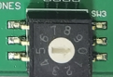
Figure 22 Module Address Switch

The module must be set to an appropriate address before use. The valid address range is listed in Table 14.

Table 14 Module Address Range
Module | Address Range
ZS | 1–9
PS | 1–9

Note: ZS, PS boards have only one rotary switch. The address is simple to set up, ranging from 1 to 9. The same type of the module address must not be repeated.

4. System Wiring
Before connecting the field wiring, check the wiring for opens, shorts, ground, and stray voltages. Note that each type of circuit is supervised.
WARNING
Using a high-voltage insulation tester for wiring while connecting it to the DCP and field devices may result in damage.

The field circuits wiring must be terminated on the respective panel board modules, in accordance with the diagrams in the SYSTEM WIRING section and in the system design documents.
All wiring must be in accordance with local codes, National Electrical Code, and Canadian Electrical Code.

4.1 Wiring Notes
- Basic system wiring and field device locations must be in accordance with NFPA 72 and CAN/ULC-S524 or other applicable codes and instructions from the appropriate local authority having jurisdiction.
- Devices that may be suitably used with the DCP are shown in the Appendix-A: Compatible Devices. Wire reference data are listed in Appendix-B: Wire Selection Guide.

4.2 Power Limiting
In accordance with NEC Article 760 and UL 864, all power limited fire protective signaling conductors must be located at least 1/4 inch away from all of the following wiring within a DCP:
- Electric light
- Power
- Class 1 or non-power limited fire protective signaling conductors

To meet these requirements, the following guidelines must be observed when installing modules and wiring to the FW151-FP DCP.
- When installing power limited field wiring, the installer must comply with NEC article 760, which states that the voice system power-limited circuits are installed using Types FPL, FPLR, FPLP or permitted substitute cable, provided these power-limited cable conductors extending beyond the jacket are separated by a minimum of 0.25 in. (6.35 mm) or by a non-conductive sleeve or non-conductive barrier from all other conductors.
- If energy limited cable or equivalent is not used within the FW151-FP enclosure, then the following guidelines do not apply. In that case, standard wiring practices should be followed.

4.2.1 Wiring Entering the Enclosure
- Non-Power Limited Wiring - Wiring entering the enclosure from its bottom left side or bottom right side is considered non-power limited wiring. Wiring must be in the shortest route and not overlap any other wiring.
- Power Limited Wiring - Wiring entering the enclosure from its upper left side or upper right side is considered power limited wiring. Wiring must be in the shortest route and not overlap any other wiring.

4.2.2 Electrical Separation
All high voltage and non-power limited wiring must be separated from power limited wiring. A separation of at least 1/4 inch must be maintained with high voltage and non-power limited wiring running in separate conduit openings from power limited wiring.

4.3 Power Supply Wiring

4.3.1 AC Connection - Supervised
The AC power supply is connected from the back of the enclosure. The AC power supply should be connected to a dedicated 15A branch circuit. It should be provided with a breaker or other means of isolation that must be colored red.
Dangerous voltages will be present on the terminal block and on other components surrounding it when the AC supply is turned on. Do not touch it.

- AC Input terminals must be located on the left side of the enclosure and in the knockout position shown in Figure 23.
All high voltage and non-power limited wiring together should be separated away from power limited wiring. Refer to the Power Limiting section for more details.

AC Power Supply Wiring

Figure 23 AC Power Supply Wiring

The ground cable should be connected to the earth stud, located on the back box.

Ground Wiring

Figure 24 Ground Wiring

Figure 25 AC Power Supply Wiring (Terminal)

Figure 26 Power Supply Wiring

Make sure the slide switch matches the rated voltage. Otherwise, the PS will be permanently damaged!

4.3.2 Battery Connection - Supervised
WARNING
Improper battery connections or the shorting of the battery terminals may damage the system and/or the batteries and may cause personal injuries.

The DCP battery charge capacity is up to 80AH. 12V batteries of the same AH rating are used. The correct AH rating is determined on the basis of the current load calculation (see Appendix-D: Battery Calculations). Batteries are connected in series in order to supply 24V. Batteries are not allowed to be connected in parallel to increase the AH rating.

Figure 27 Battery Connection

4.4 Addressable Fire Fighter’s Telephone Circuit Wiring - Supervised
- One TB module supports 40 addressable TESs or addressable TWJs. Maximum 6 handsets off the hook at any one time, including the master handset.
- FFT BUS supports Class A/DCLA and Class B/DCLB wiring. A maximum of 40 (addressable TWJ) × 4 (non-addressable TWC) means 200 telephones can be connected to a single circuit.
- All the non-addressable TWC are polarity insensitive, while the addressable TES and TWJ modules are polarity sensitive.
- Refer to the instruction sheets for each device.
- Each TWJ and its four TWCs that share the same address with it must be placed within the same room.

4.4.1 Addressable Fire Fighter’s Telephone Circuit Wiring – Class A/DCLA
Figure 28 Class A/DCLA Wirings of FW151-FP and TES/TWJ

Class A/DCLA provides redundant communication paths.
Figure 29 Class A/DCLA Wirings of TES and TWJ

Note: If TES and TWJ use Class A/DCLA wiring, 22KΩ/2W EOLR still needs to be connected to each TWC circuit.
Figure 30 Class A/DCLA Wirings of TES/TWJ

4.4.2 Addressable Fire Fighter’s Telephone Circuit Wiring – Class B/DCLB
Class B/DCLB wiring allows branching of circuit connections.
Figure 31 Addressable FFT BUS Circuit Wirings – Class B/DCLB

Note: If TES and TWJ use Class B/DCLB wiring, a 3.9KΩ/2W End-Of-Line Resistor must be connected to the FFT BUS. If the TWC is installed, a 22KΩ/2W EOLR still needs to be connected to the TWC circuit.
Figure 32 Addressable FFT BUS Circuit Wirings – Class B/DCLB

4.5 Communication Port Connection - Unsupervised
- MB provides an Ethernet standard RJ45 port for temporary connection to a computer for panel programming.
- The Ethernet standard RJ45 port is connected to the Ethernet port of the computer which runs the EDCS Programming Tool. This is used to upload and/or download voice panel custom-programmed configurations.
- DCP does not connect to the Internet to avoid a risk of remote falsifying.
The computer must be disconnected from the panel if not in use.

- Programming connection for an individual DCP

Figure 33 Programming using the Motherboard (MB) Rj45

4.6 System Checkout
The following are the recommended steps that should be followed before and during the FW151-FP power-up.

4.6.1 Before Turning the Power On
4.6.1.1 DO NOT connect the battery first for danger of sparking. The batteries should be connected only after the system has been powered from the main AC Supply.
4.6.1.2 Check all field (external) wiring for opens, shorts, and ground fault conditions.
4.6.1.3 Check that all interconnection cables are secured and that all connectors are plugged in properly.
4.6.1.4 Check all switches for proper setting.
4.6.1.5 Check the AC power and the batteries wiring for proper connection. Observe/check the 120 VAC/240 VAC slide switch position.
4.6.1.6 Close the front cover before powering the system from main AC supply.

4.6.2 Power-up Procedure
4.6.2.1 Upon completion of the steps listed in “Before Turning the Power ON”, power up the panel. The POWER ON LED indicator should be steadily green.
4.6.2.2 The Battery Trouble LED (on the power supply) should be flashing as the batteries have not been connected.
4.6.2.3 Connect the batteries after the power polarity for the correct connection is checked. The red wire is positive (+) and the black wire is negative (-).
4.6.2.4 All indicators should extinguish except for the green normal power AC ON LED.

4.7 Troubleshooting
The common solutions to circuit troubles, ground fault, battery and common troubles are shown as below.

4.7.1 Circuit Trouble
Normally when a circuit trouble occurs, the Trouble LED will be illuminating. Usually, an associated event can be shown on the LCD event list for viewing. These indications are used to correct the fault, check for open wiring on a particular addressable loop circuit.

Table 15 Circuit Trouble
 | The minimum resistance to test open fault (Ohms) | The maximum resistance to test short fault (Ohms)
In an addressable FFT BUS circuit | 20KΩ | 100Ω
In a non-addressable FFT BRANCH circuit | 100KΩ | 20Ω

4.7.2 Ground Fault
This panel has ground fault detection. To correct the ground fault trouble, check for any external wiring touching the chassis or other Earth Ground connection.
- The resistance to the earth is less than 6.6K ohms will report a ground fault.

4.7.3 Battery Trouble
Check for the presence of batteries and their conditions. Low battery voltage (below 20.4V) will cause a battery trouble. Note that brand new batteries may take several hours to charge initially. If the battery trouble condition persists, please replace batteries as soon as possible.

4.7.4 Common Trouble
If only a common trouble is indicated on the main audio panel while none of those trouble indicators mentioned above are on, then check the following for possible fault.
- Any missing interconnection wiring
- Improperly secured cable

5. Functions

5.1 Interface Functions
Power-up interface is shown as Figure LCD1.
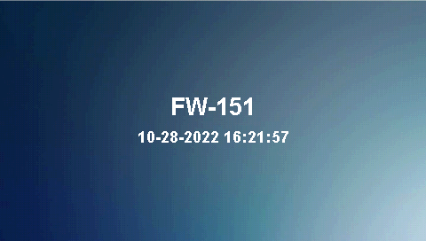
Figure LCD1
Press MENU to enter main menu shown in figure LCD2 where three options are listed as shown below for user operations:
- Archive
- Query
- Login
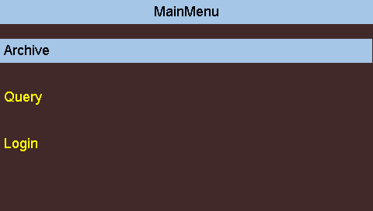
Figure LCD2

5.1.1 Archive
Trouble and operation history can be viewed by pressing arrow keys (Up and Down). Press TAB to show history information in ascending or descending order. Press MENU to display a pop-up menu including All, Trouble and Active, as shown in Figure LCD3.
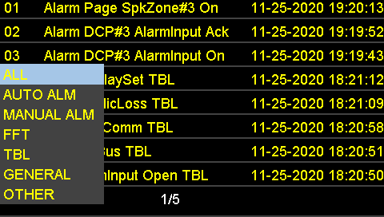
Figure LCD3

5.1.2 Query
There is a level-2 directory shown in Figure LCD4 that contains:
- Message
- Power Status
- Version
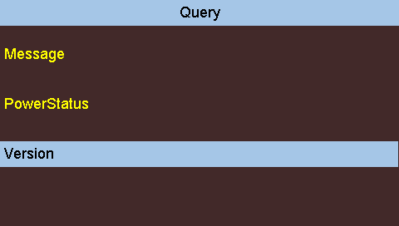
Figure LCD4

5.1.2.1 Message
All recording and music files are contained under this menu. Press arrow keys (Up and Down) to go through it and press ENTER to play music, as shown in Figure LCD5.
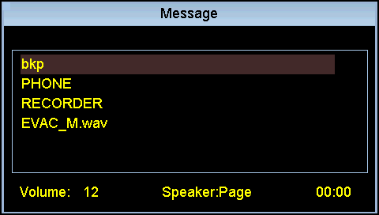
Figure LCD5

5.1.2.2 Power Status
The status of primary power supply and backup battery, and monitoring values of output voltage, output current and temperature are contained under this menu, as shown in Figure LCD6.
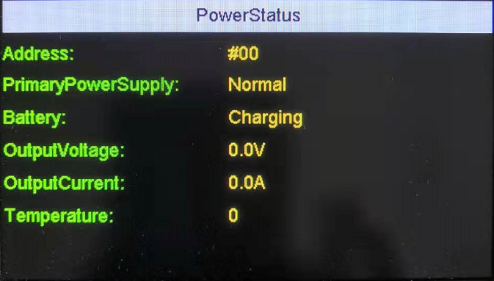
Figure LCD6

5.1.2.3 Version
Users can view equipment version number, as shown in Figure LCD7.
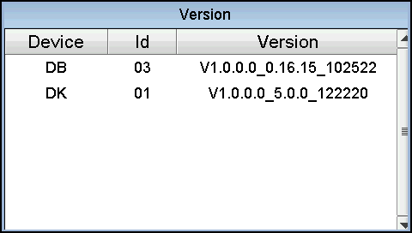
Figure LCD7

5.1.3 Login
Input User Name and Password and then press ENTER to access System Config. Press the LNG button to switch between numbers and alphanumerical characters. Press the TAB button to move the cursor between lines. Press the “＜” button to delete one character. Default user name is admin and the initial password is 111111111111, as shown in Figure LCD8.
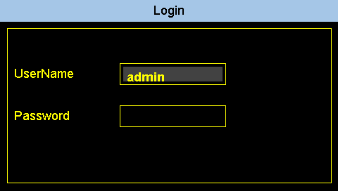
Figure LCD8
After the completion of User Name and Password, enter System Config, as shown in Figure LCD9.
- Users of level-4 (the highest priority): have access to settings of System Config, Programming, New User Register and System Fault Test.
- Users of level-3: have access to settings of System Config and Programming.
- Users of level-2 (the lowest priority): only have access to System Config.
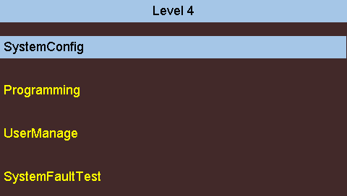
Figure LCD9

5.1.3.1 System Config
- Date&Time
- Language
- Configuration
- PasswordModification
- PlaySet
As shown in Figure LCD10.
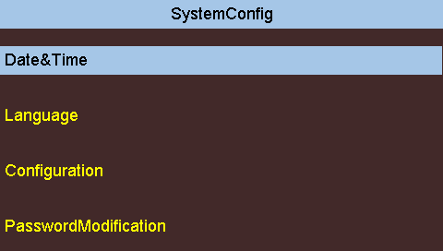
Figure LCD10
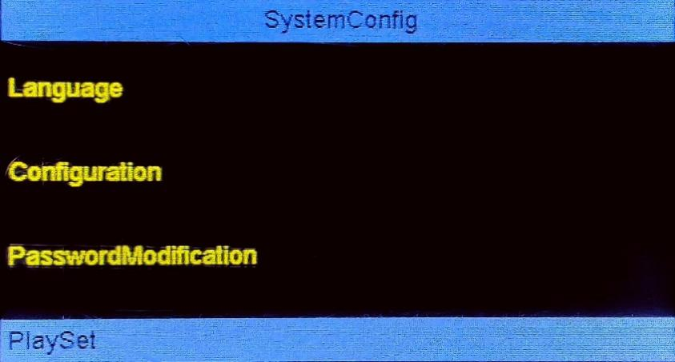
Figure LCD11

5.1.3.1.1 Date & Time
Modify the date and time by numeric and arrow keys. Press the TAB button to move the cursor between field. Press ENTER to save the setting.
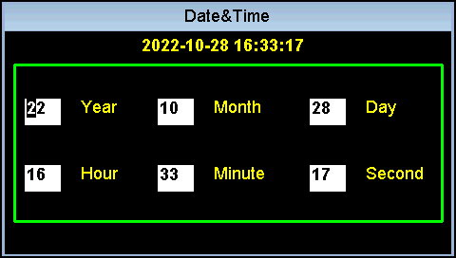
Figure LCD12

5.1.3.1.2 Language
Press arrow keys (Up and Down) to shift among Chinese, English and French. Press ENTER for confirmation, as shown in Figure LCD12.
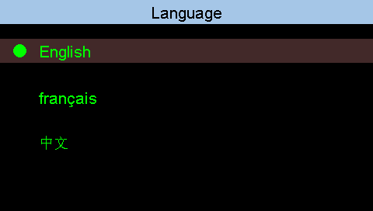
Figure LCD13

5.1.3.1.3 Configuration
Press numeric and arrow keys to set up and modify Local Addr, Mesh Addr, Sleep Time, REC-Max Time, Mic Auto Return, Buzzer, System Earth and EC Earth. Press the TAB button to move between options. Press Save to save the settings, as shown in Figure LCD13.
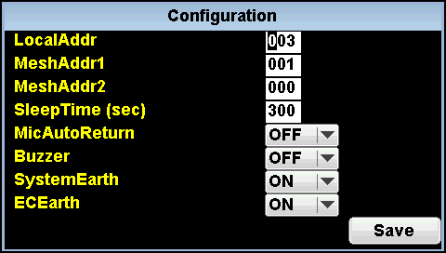
Figure LCD14

5.1.3.1.4 Password Modification
Input New Password and then confirm it, as shown in Figure LCD14. Press ENTER to confirm the modification. The setting will be completed with a notified success. Press the TAB button to move between lines. Press the LNG button to switch between numbers and alphanumerical characters.
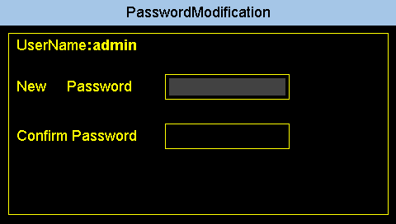
Figure LCD15

5.1.3.2 Programming
As shown in Figure LCD17, the menu contains:
- SPEAKERZONE
- AMP
- ZS
- Telephone
- Auto Regist
- FileSet
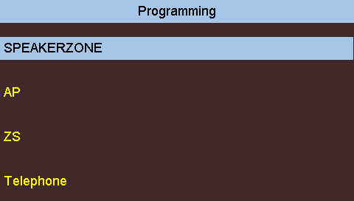
Figure LCD16
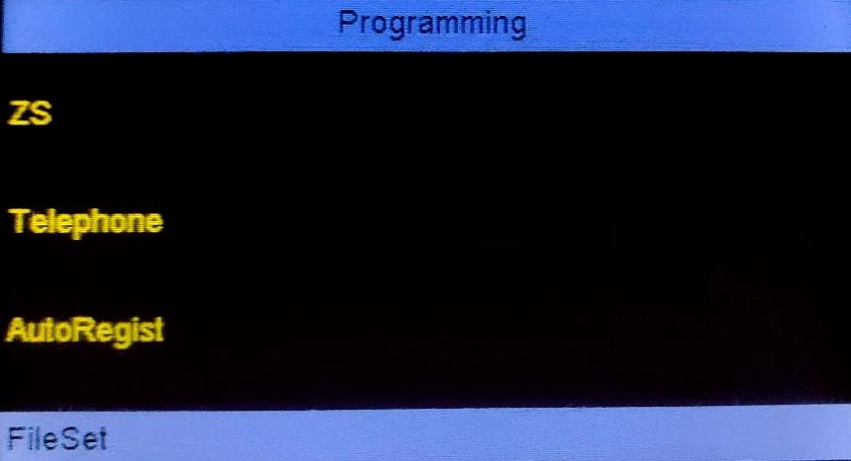
Figure LCD17

5.1.3.2.1 ZS
As shown in Figure LCD18, set up ZS and KEY, select a function from pop-up menu for FUNC, and input the zone or address number for MAPPING.
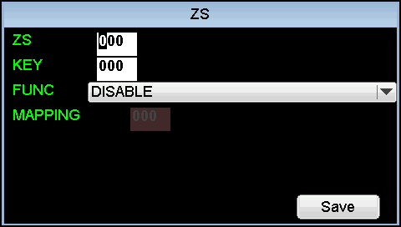
Figure LCD18

5.1.3.2.2 Telephone
As shown in Figure LCD21, set up NODE, ADDR and make a selection in the PORT field. Users can view the number of the Telephone Extension Stations (TES). Press Save for confirmation. Settings will be completed with a notified success.
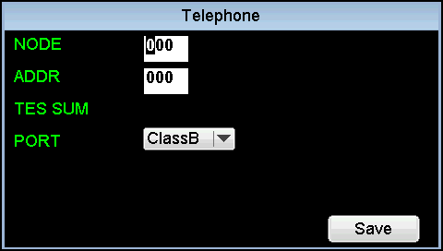
Figure LCD19

5.1.3.2.3 Auto Regist
This functions as slave equipment’s auto register. As shown in Figure LCD22, when AutoRegist is selected, the presence of equipment online status will be automatically detected and the address will be registered.
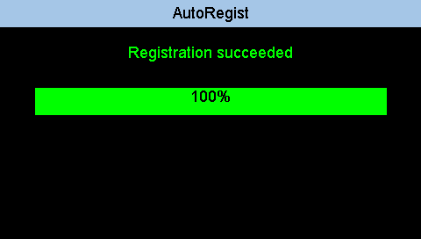
Figure LCD20

5.1.3.2.4 File Set
Select the required file and press ENTER to confirm. Move the cursor to Uploading by using the TAB button. Press ENTER to start uploading files to PC. See Figure LCD16.
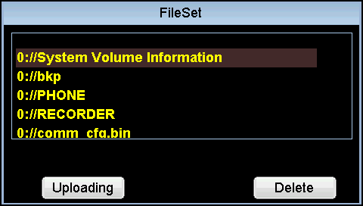
Figure LCD21

5.1.3.3 New User Register
Under this menu, select Register or Remove by using the TAB button and arrow keys (Up and Down), as shown in Figure LCD23.
UserName: input or choose Remove
PwdLevel: Level 2 and Level 3 can be chosen
Choose: Register for new user registration and Remove for delete user can be chosen
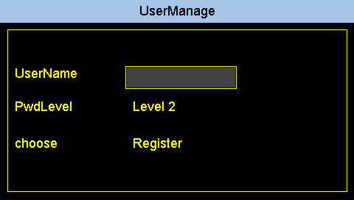
Figure LCD22

5.1.3.4 System Fault Test
This menu tests and simulates if the CPU_FLT trouble indicator does turn ON when RAM, SDRAM, NORFLASH and ROM on MB board have failed. Press the TAB button for selection. Press ENTER for confirmation.
Note: Be cautious when operating NOR Flash Test and ROM Test that will permanently erase firmware program resulting in abnormal running.
As shown in Figure LCD24.
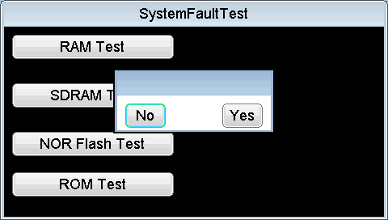
Figure LCD23

5.2 Display, Buzzer and Button Functions

5.2.1 Liquid Crystal Display (LCD)
- The LCD can display 4 events at a time. Users can browse more events from the first to the last by pressing the Up/Down keys.

- Events are displayed according to the following rules:
- Events are prioritized in descending order from Alarm, Supervisory, Trouble/Fault, Other Signal and Output.
- Events of the same priority are displayed in order of occurrence, with the latest event displayed first.

5.2.2 LED Indicators
Refer to Table 16 for the LEDs operation.
Table 16 LED Operation on the main audio panel
POWER ON | Green | Steady ON | The system is working normally
POWER ON | Green | OFF | The system has not been powered on
ALARM | Red | not available for fire telephone
SIL INHIBIT | Yellow | not available for fire telephone
TROUBLE | Yellow | Steady ON | There is at least one trouble event
TROUBLE | Yellow | Flashing | There is at least one trouble event that has been unacknowledged
TROUBLE | Yellow | OFF | There is no trouble event in the system
PRE-ANN | Yellow | not available for fire telephone
GND_FLT | Yellow | Steady ON | There are ground fault events in the system
GND_FLT | Yellow | OFF | There is no ground fault event in the system
CPU_FLT | Yellow | Steady ON | There is a fault in CPU
CPU_FLT | Yellow | OFF | There is no CPU fault
READY TO PAGE | Green | not available for fire telephone
ACK | Yellow | Steady ON | Not all system events have been acknowledged
ACK | Yellow | OFF | There is no system event which waits to be acknowledged
DRILL | RED | not available for fire telephone
LAMP TEST | Green | Flashing | Verify all LEDs are lit in a correct color
LAMP TEST | Green | OFF | The process of verifying colors of all LEDs ends
SYSTEM RESET | Green | Flash once | Reset the system
SYSTEM RESET | Green | OFF | The system is not in the process of reset
AUDIO MONITOR | Green | not available for fire telephone
AUDIO SILENCE | Yellow | Steady ON | Local speaker is in silence status
AUDIO SILENCE | Yellow | OFF | Enable local speaker to play background music
BUZZER SILENCE | Yellow | Steady ON | The trouble buzzer is silenced
BUZZER SILENCE | Yellow | OFF | The trouble buzzer is enabled
ACTIVE CENTER | Green | not available for now

5.2.3 Buzzer
The buzzer operates as follows:
- Normally OFF – indicates that the system is in normal condition or all events in the system have been acknowledged.
- ON (1 pulse per 1 second) – indicates that at least ONE unacknowledged trouble event is present in the system.
- ON (1 pulse per 2 seconds) – indicates that at least ONE other unacknowledged event is present in the system.

5.2.4 Buttons
The DCP has 4 navigation buttons, one Enter button and 6 functional buttons. The button functions are listed in Table 17.
Table 17 Button Functions
Notes that the functional buttons listed as below have different roles depending on the view. The roles in main view are listed below.
ACK | Press once to acknowledge a single unacknowledged event in the system.
DRILL | Start up the drill test (not available for fire telephone)
LAMP  TEST | Verify the colors of all LEDs are correct
SYSTEM RESET | Clear all obsolete events and reset all devices, except those disabled in the system
AUDIO MONITOR | Monitor whether the background music is playing from the local speaker (not available for fire telephone)
AUDIO SILENCE | Silence or resound the local speaker
BUZZER SILENCE | Silence or resound the buzzer
ACTIVE CENTER | Control the authority transfer among multiple DCPs. Once the indicator on ACTIVE CENTER button turns steadily green, the local DCP has seized control of the entire system. (Only a single DCP is supported for now)
MAIN KEY BOARD
1/2/3/4/5/6/7/8/9/0 /*/# | Numerical symbols button (Input for programming）
↑  ← →  ↓ | Navigation keys. Select the items in the menu, or select letters or digits for input. Keep pressing the key to move cursor rapidly.
ENTER | Select or confirm information
MENU | For user operations
LNG | LCD language selection
LOGIN | Registration or shortcut login button
TAB | Input or toggle between options
RETURN | LCD menu page return button
VOL+ | Volume increase
VOL- | Volume reduction

5.2.5 ZS Keypad
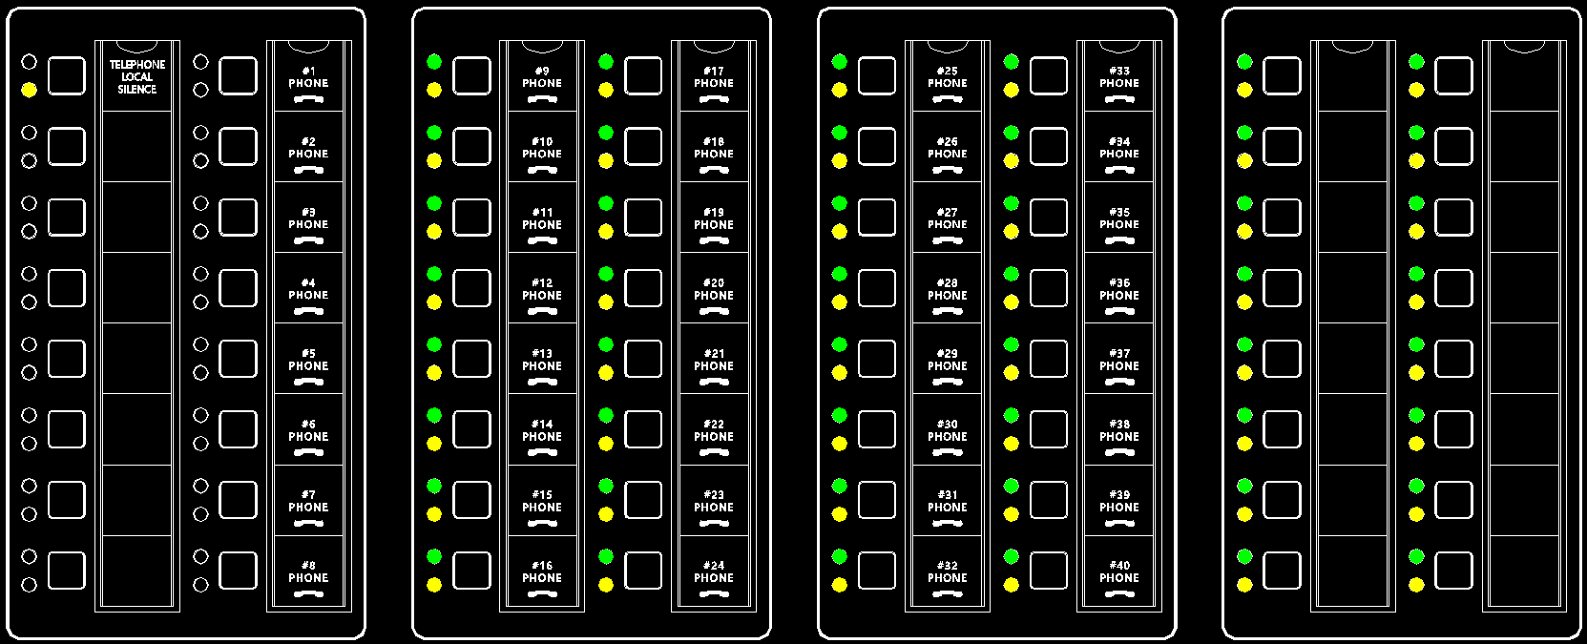
Figure ZS

TELEPHONE LOCAL SILENCE | When it is pressed, an incoming call’s ringtone will be shut off from the local speaker with its LED turning yellow.  When it is pressed again, an incoming call’s ringtone will resume sounding with its LED extinguished.
#1 - #40 PHONE | - When a call (or more calls) comes in from an FFT, an LED for the corresponding PHONE button is flashing green with ringtone sounding from the local speaker and incoming call notice displaying on the screen. Press this button to see the LED turning steady green and to answer the call on the master telephone handset placed on the left side of the screen. When the talk is over, press it again to see the LED going off.  - When a call (or more calls) comes in with ringtone sounding from the local speaker, press TELEPHONE LOCAL SILENCE button with a yellow LED to silence or resound it while the PHONE button is still flashing green.  - If a telephone wall jack remains plugged-in after the talk is over, the TROUBLE indicator will be flashing yellow with buzzer sounding and a piece of flashing trouble information displaying on the screen as well as the ACK button and the corresponding PHONE button’s LED are both lit yellow. The flashing trouble information will not be confirmed, and both the TROUBLE indicator and the corresponding PHONE button will not turn steady yellow until the ACK button is pressed.

5.3 Operation

5.3.1 Answer and Hangup
When a call comes in from an FFT, the corresponding LED indicating #1 - #8 PHONE is flashing green with incoming ringtone sounding from the local speaker.
Press the corresponding button from #1 - #8 PHONE to answer the call with its LED turning steady green or press TELEPHONE LOCAL SILENCE button to silence the ringtone.
Press the button again to hang up the call with the green LED extinguished.

5.4 Status Handling
This section describes the DCP responses and operations in standby condition, alarm condition, and trouble/fault condition.

5.4.1 Standby Condition
- In the normal standby state, the green POWER ON indicator should be steady-on and the LCD will display the system model and the current time.

5.4.3 Trouble Conditions
- In case of a trouble condition, the system trouble indicator is activated (ON), the LCD identifies the problem, and the buzzer sounds in trouble pattern. Press the buzzer silence button to silence the buzzer and then the button’s LED indicator illuminates.
Refer to Table 18 for trouble event descriptions.

Table 18 Trouble Event
Category | Trouble Event | Description
System | PrimaryPower_Loss | Primary power is lost
System | Battery_Loss | Battery power is lost
System | ControlPanel_Grounding | The DCP has ground fault condition
System | PrimaryPower_OverVoltage | Primary power voltage is too high
System | Charger_OverVoltage | Charger voltage is too high
System | ArchiveFile_Missing | History record file is missing
System | ConfigFile_Missing | Configuration file is missing
System | ConfigFile_Damaged | Configuration file is damaged
System | Master Handset_Missing | Master telephone handset wiring error or loose connector
Module | DK_Loss | DK communication fault is reported on main panel
Module | ZS_Loss | ZS communication fault is reported on main panel
Module | TB_Loss | TB communication fault is reported on main panel
Circuit | Ext._Grounding | External (field) wire grounded
Circuit | FFT_BUS_Short | The FFT BUS circuit wire shorts
Circuit | FFT_BUS_Open | The FFT BUS circuit wire opens
Field Device | Telephone_Loss | Registered TES or TWJ is in an offline status
- When a trouble occurs, ACKNOWLEDGE button is pressed to silence the buzzer while the button’s LED is steadily ON.
- The panel has a 24-hour Trouble Resound function. If a trouble event has occurred then acknowledged and the time for sounding by a Trouble Resound Reminder has elapsed, the trouble will be re-annunciated.
- When all indicated trouble event has been cleared, the system will return to normal standby condition automatically.
- Note that the supervisory LED indicator is not used for now

5.5 Event History
The DCP includes a non-volatile memory recording maximum 5000 events. Identified trouble, faults status, and other significant events will be recorded along with the date and time of occurrence. These can be viewed by operating buttons on the front panel.
- To scroll through archived events, the panel should be operated as follows:
- Press the MENU button.
- On the MENU display, select “Archive”.
- Press the ENTER button.
- Use the Up button to go through the previous event.
- Use the Down button to go through the next event.
- The history record rule is:
- New events will overwrite old ones when the available free space is filled up.
- The events are sorted by time occurrence sequence.
- Events recorded in the history include:
- Incoming call, answer and hang up
- Buzzer silence/Resound
- System reset
- Trouble/supervisory reminder
- Trouble/faults restored to normal

5.6 Configuration and Maintenance

5.6.1 PC Configuration
- The panel can be programmed by temporarily connecting it to a computer’s programming port. This is the recommended method of panel configuration.
- The DCP can be programmed by the Maple Armor configuration software installed on a Personal Computer (PC) with an Ethernet port. This allows ease of operation by preparing the program in advance and downloading it to the DCP in a simple and fast operation.

5.6.2 Fire Telephone System Access Control
- The DCP provides configuration functions to set and control various features in the system.
- The configuration functions are protected by access control. The following levels of security can protect the system from unauthorized use:
- Level 1 – Locked door
- Level 2 – Locked door and 8-digit password, providing control functions.
- Level 3 – Locked door and 12-digit password, providing control functions and parameter change functions.

5.6.3 Battery Maintenance
FW151-FP can support 20 AH sealed lead-acid batteries within code requirements for up to 24 hours normal standby plus as per UL 864 in the 10th Edition (section 69.2.3 and 69.2.5)/ULC-S527 in the 4th Edition (section 10.5) and CAN/ULC-S536, or as otherwise required by local codes. These batteries will lose capacity as they are aging. Batteries must be replaced either when they fail to provide the panel with the required power for standby and alarm, or the battery life reaches to 4 years. These batteries must be checked for its performance at least twice a year or more frequently to comply with the local codes if required.

6. Programming
The EDCS-Programming-Tool is a graphical programming tool for EDCS configuration. It consists of Project Manage, Device Manage, SPKZone Manage, FFTZone Manage, Mapping Manage and Audio Manage sections, as shown in the Figure EDCS1.

6.1 Project Management
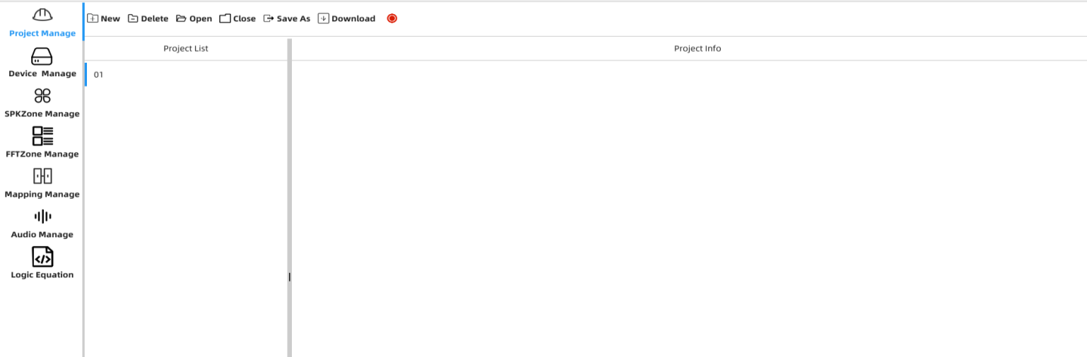
Figure EDCS1
Under Project Manage, users can create a new project, open an existing project file, back up a file to a specific location and download a configuration file to the DCP controller.

6.1.1 Create New Project
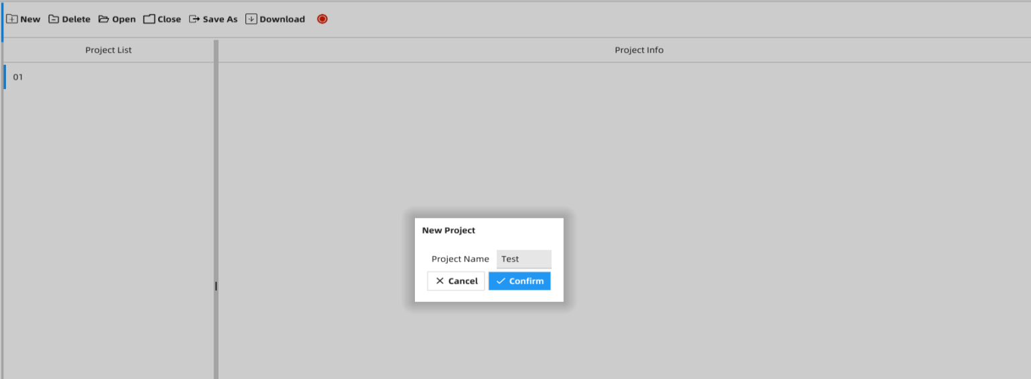
Figure EDCS2

6.1.2 Delete Project
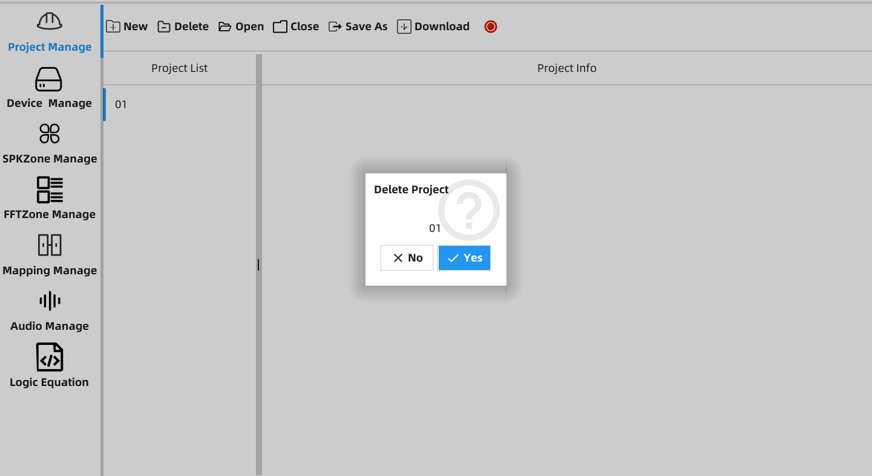
Figure EDCS3
Select the project to be deleted, click Delete on the menu bar and click Yes in the pop-up window.

6.1.3 Import Project File
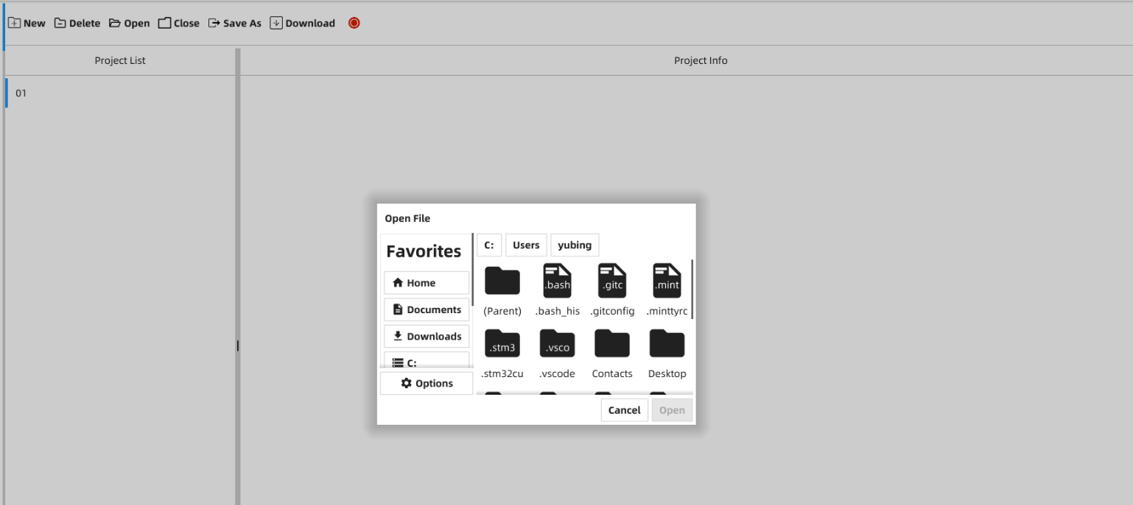
Figure EDCS4
Click Open on the menu bar and select a project file you want to open.

6.1.4 Close Project
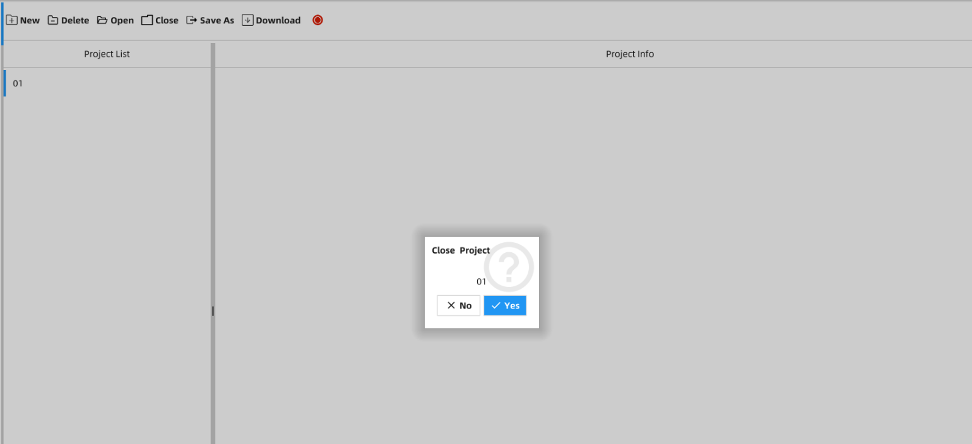
Figure EDCS5
Select the project you want to close, click Close on the menu bar and click Yes in the pop-up window.

6.1.5 Project Backup
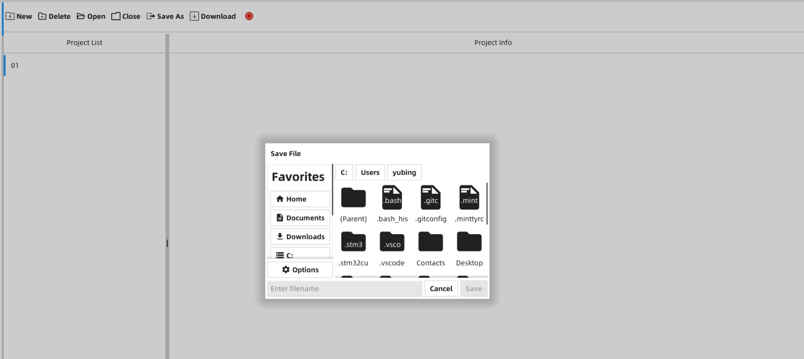
Figure EDCS6
Select the project you want to back up, click Save As on the menu bar, select a backup path and the name of custom backup file.

6.1.6 Project Configuration Download
6.1.6.1 Controller Connection
The DCP controller will be automatically connected after successful connection in the configuration mode. The configuration file cannot be downloaded until the Download status indicator turns green from red.

6.1.6.2 Configuration File Downloaded to Device
Select the configuration file you want to download and click Download on the menu bar.

6.2 Device Management and Configuration
For device adding, deleting and parameters configuration.

6.2.1 Device Adding and Configuration
6.2.1.1 Controller (FW151-MB) Adding and Configuration
a) FW151-MB Adding
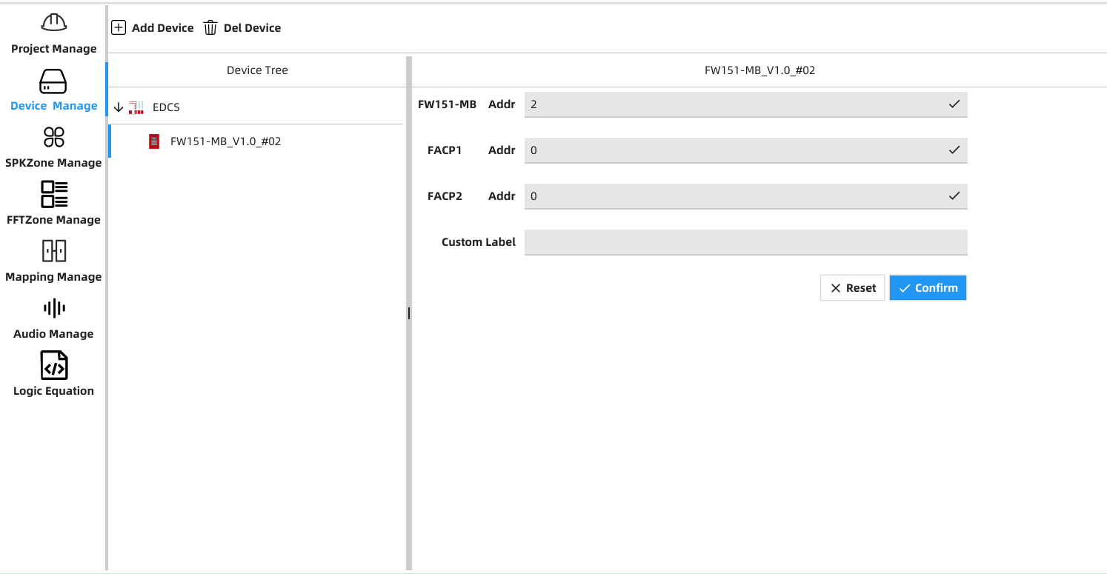
Figure EDCS7
Select EDCS, click Add Device on the menu bar, select FW151-MB_V1.0 and the adding number in the pop-up window.
b) Parameters Configuration
FW151-MB Addr: controller address (2-110)
FACP1 Addr: fire alarm control panel#1 address (2-110)
FACP2 Addr: fire alarm control panel #2 address (2-110)
Custom Label: controller label
After configuration, click Confirm and save it.

6.2.1.2 FW151-ZS
a) FW151-ZS Adding
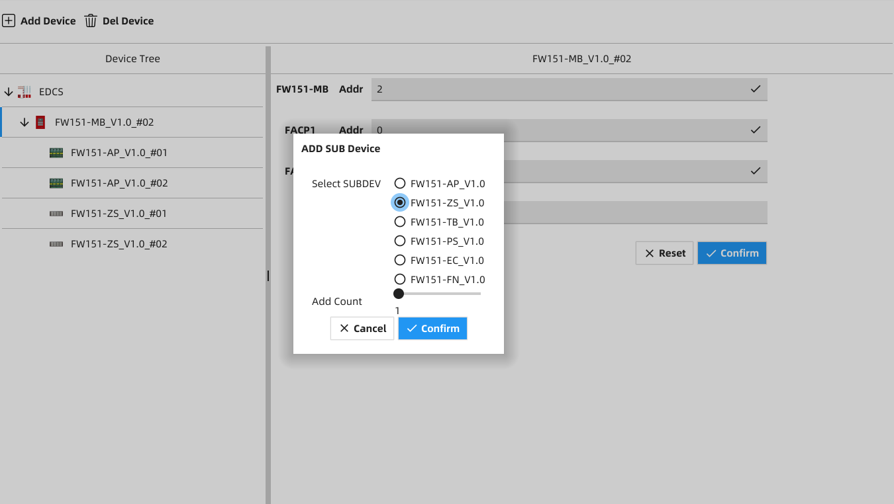
Figure EDCS8
Select FW151-MB, click Add Device, select FW151-ZS_V1.0 and the quantity number in the pop-up window.
b) Configuration
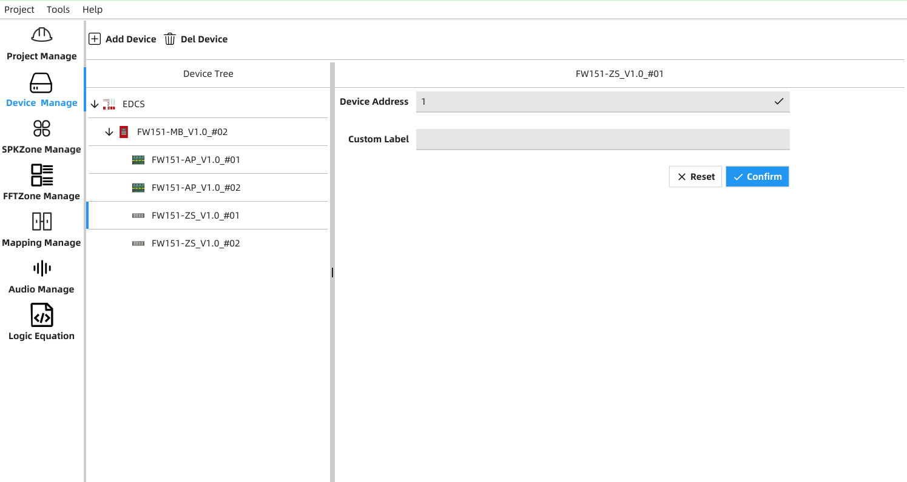
Figure EDCS9
Custom Label: ZS label
Device Address: ZS address
After configuration, click Confirm and save it.

6.2.1.3 FW151-TB
a) FW151-TB Adding
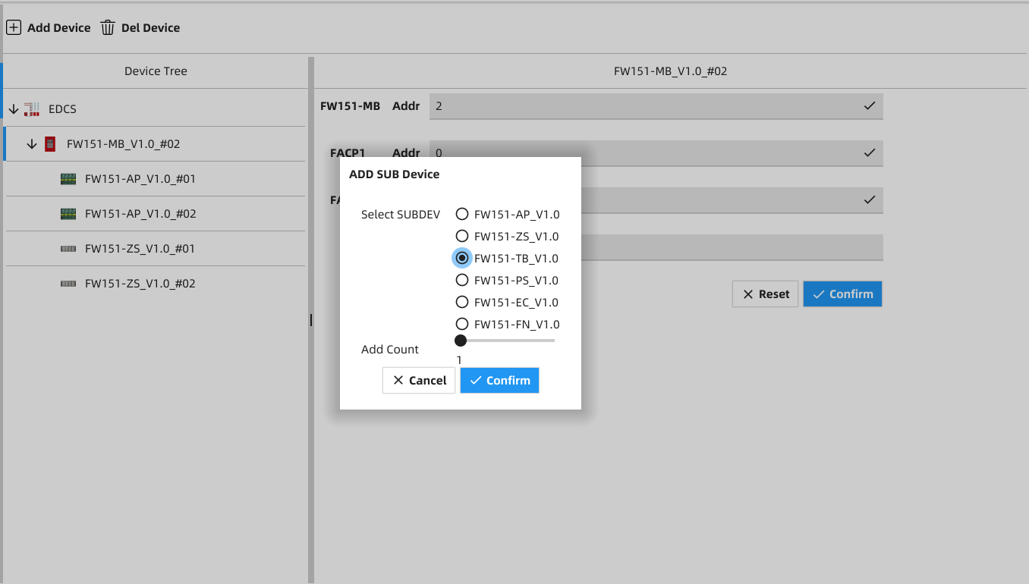
Figure EDCS10
Select FW151-MB, click Add Device, select FW151-TB_V1.0 and the quantity number in the pop-up window.
b) Configuration
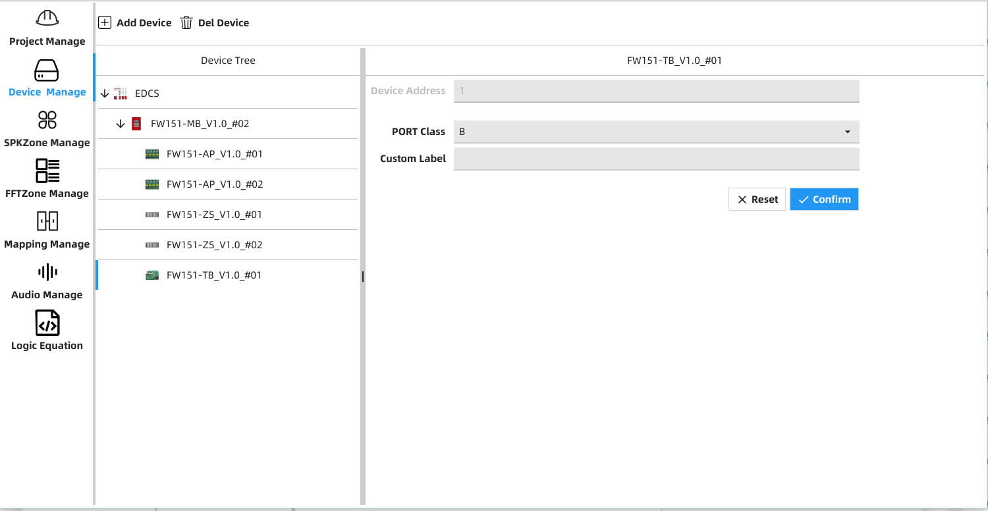
Figure EDCS11
Custom Label: TB label
Device Address: TB address
After configuration, click Confirm and save it.

6.2.1.4 FW151-PS
a) FW151-PS Adding
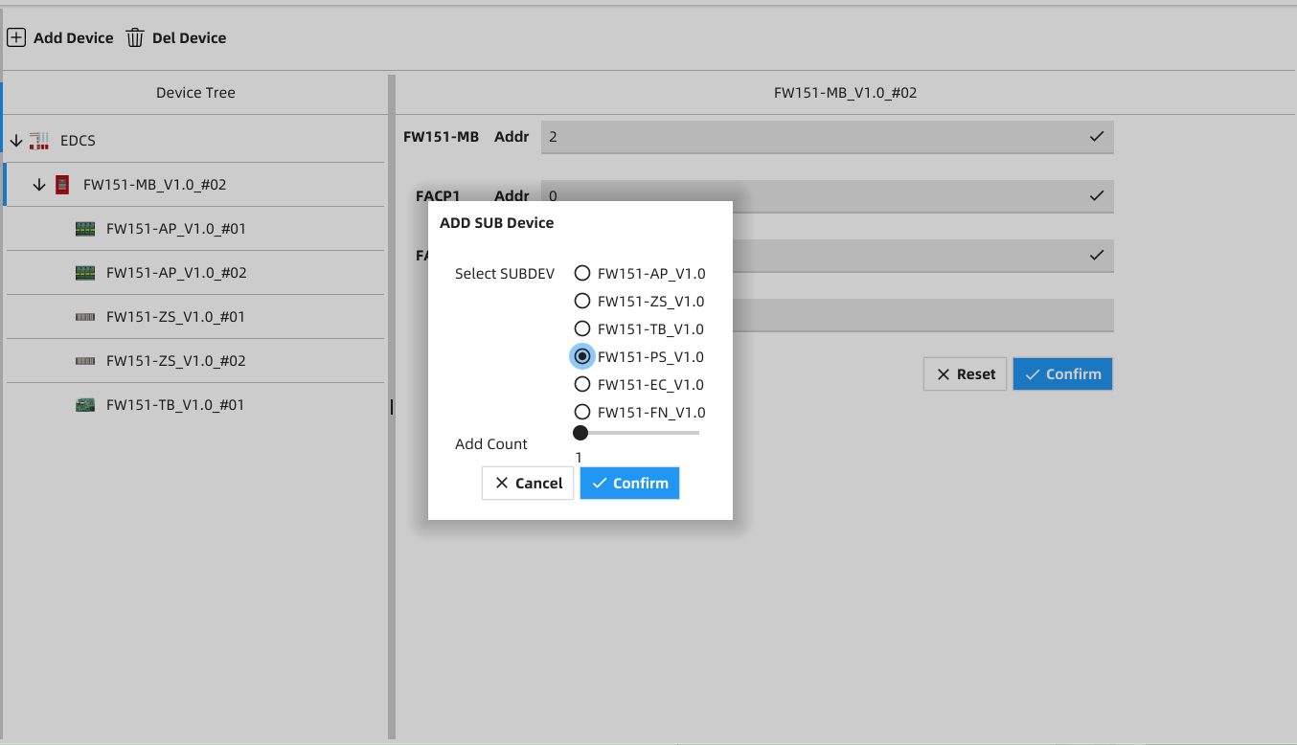
Figure EDCS12
Select FW151-MB, click Add Device, select FW151-PS_V1.0 and the quantity number in the pop-up window.
b) Configuration
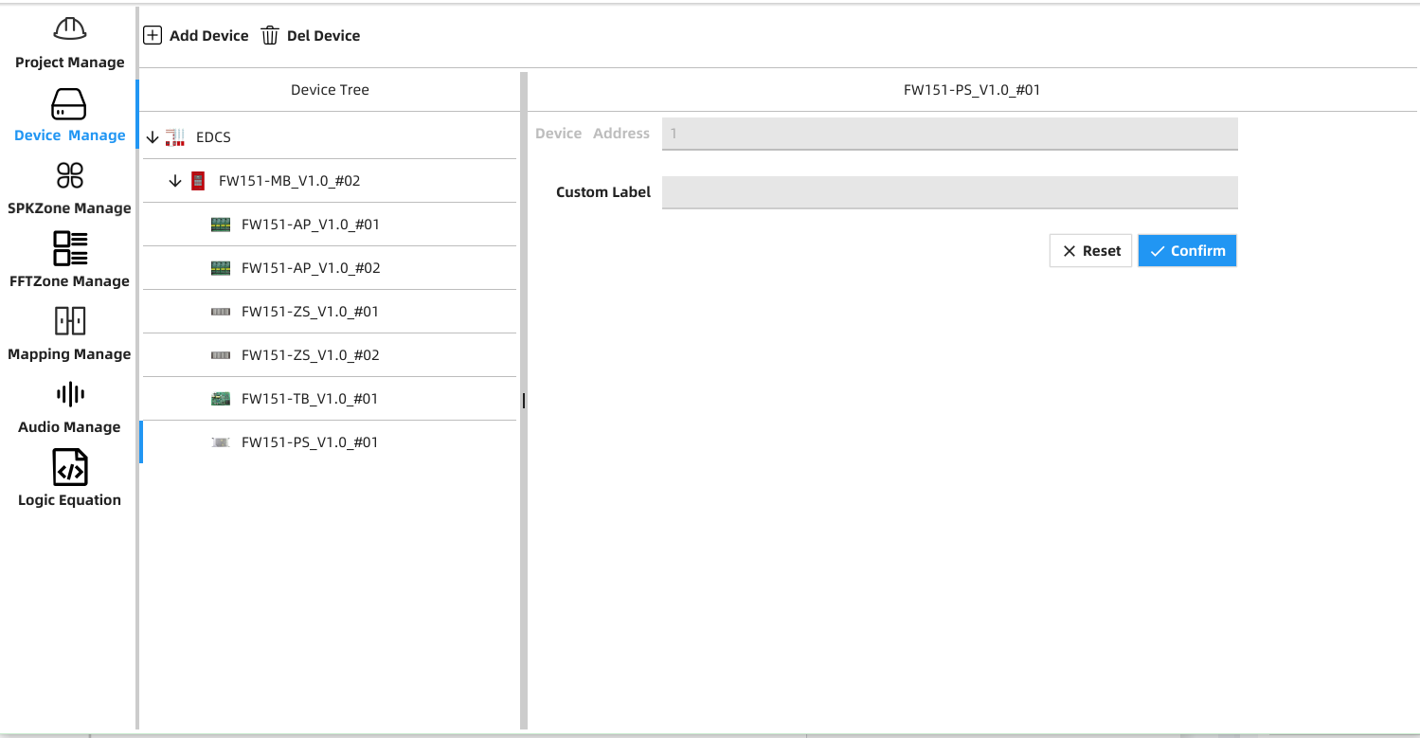
Figure EDCS13
Custom Label: PS label
Device Address: PS address
After configuration, click Confirm and save it.

6.2.1.5 TES
a) TES Adding
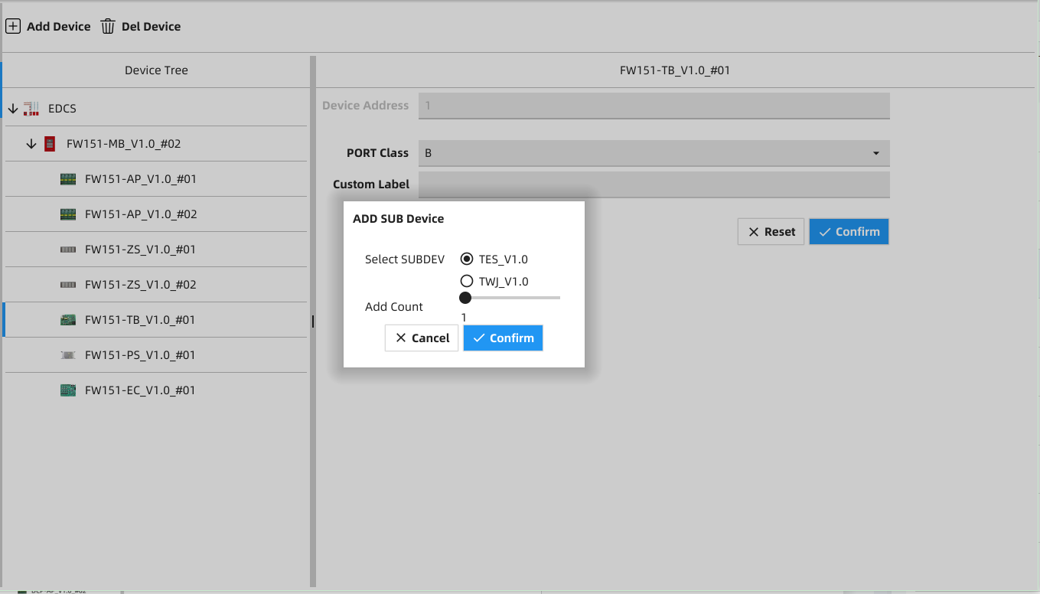
Figure EDCS14
Select FW151-TB, click Add Device, select TES_V1.0 and the quantity number in the pop-up window.
b) Configuration
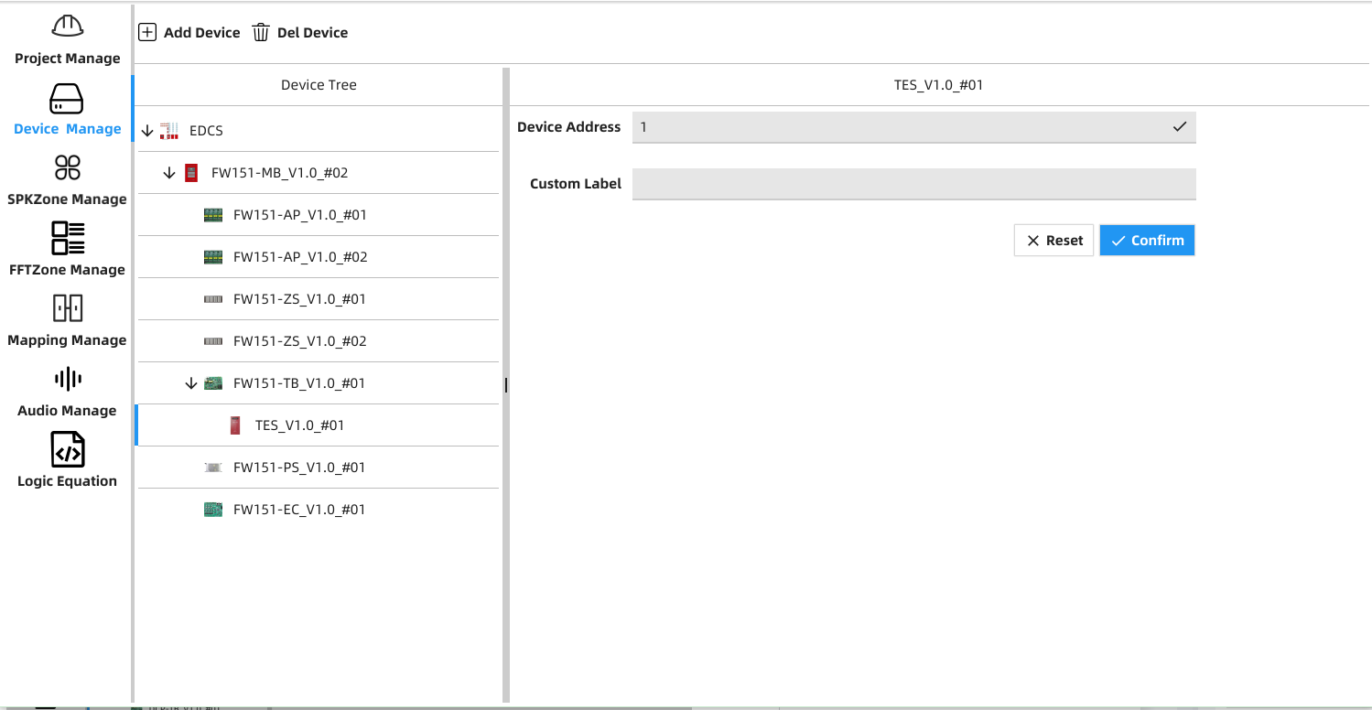
Figure EDCS15
Custom Label: TES label
Device Address: TES address
After configuration, click Confirm and save it.

6.2.1.6 TWJ
a) TWJ Adding
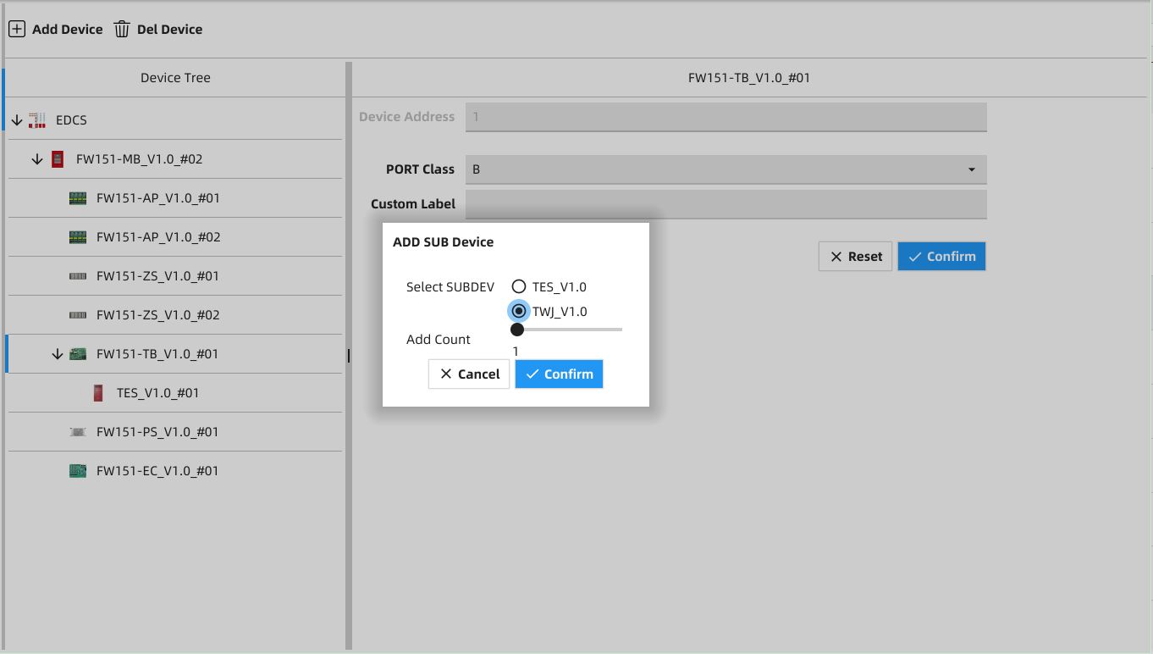
Figure EDCS16
Select FW151-TB, click Add Device, select TWJ_V1.0 and the quantity number in the pop-up window.
b) Configuration
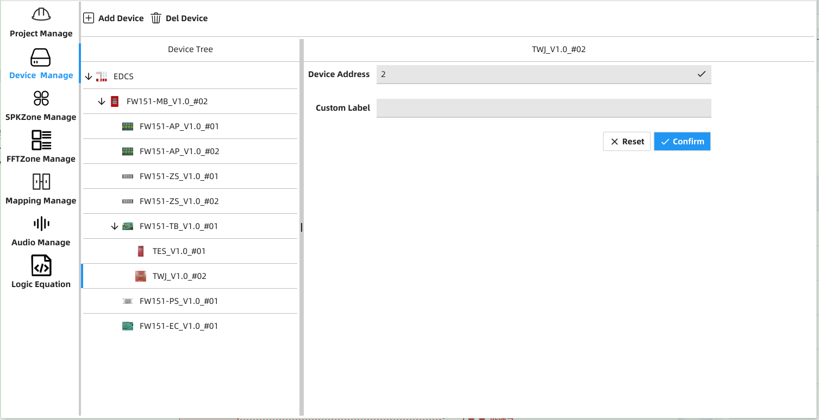
Figure EDCS17
Custom Label: TWJ label (location)
Device Address: TWJ address
After configuration, click Confirm and save it.

6.3 Delete Device
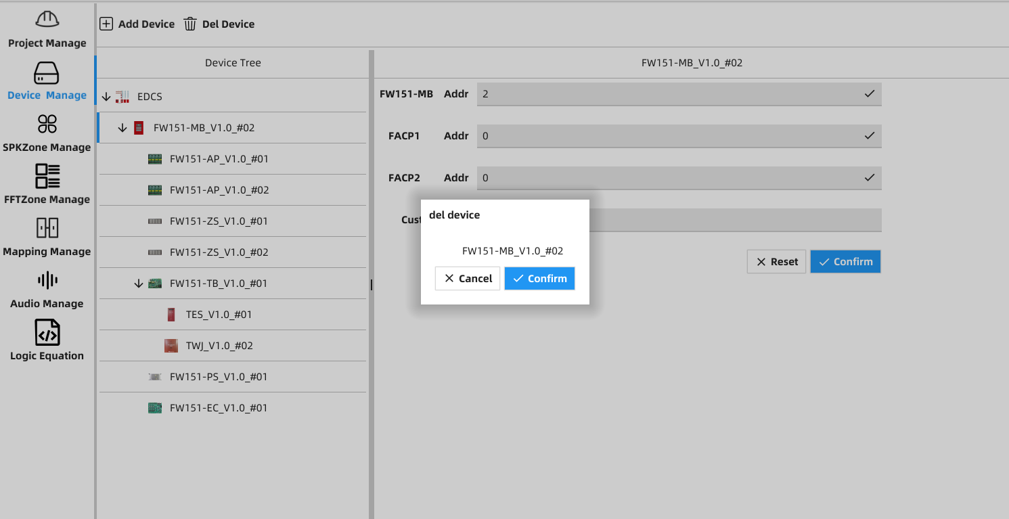
Figure EDCS18

Select the panel to delete in the Device Tree, click Del Device and click Confirm in the pop-up window.

6.4 FFT Zone Management
This section explains how to add, delete and configure FFT zones.

6.4.1 FFT Zone Adding
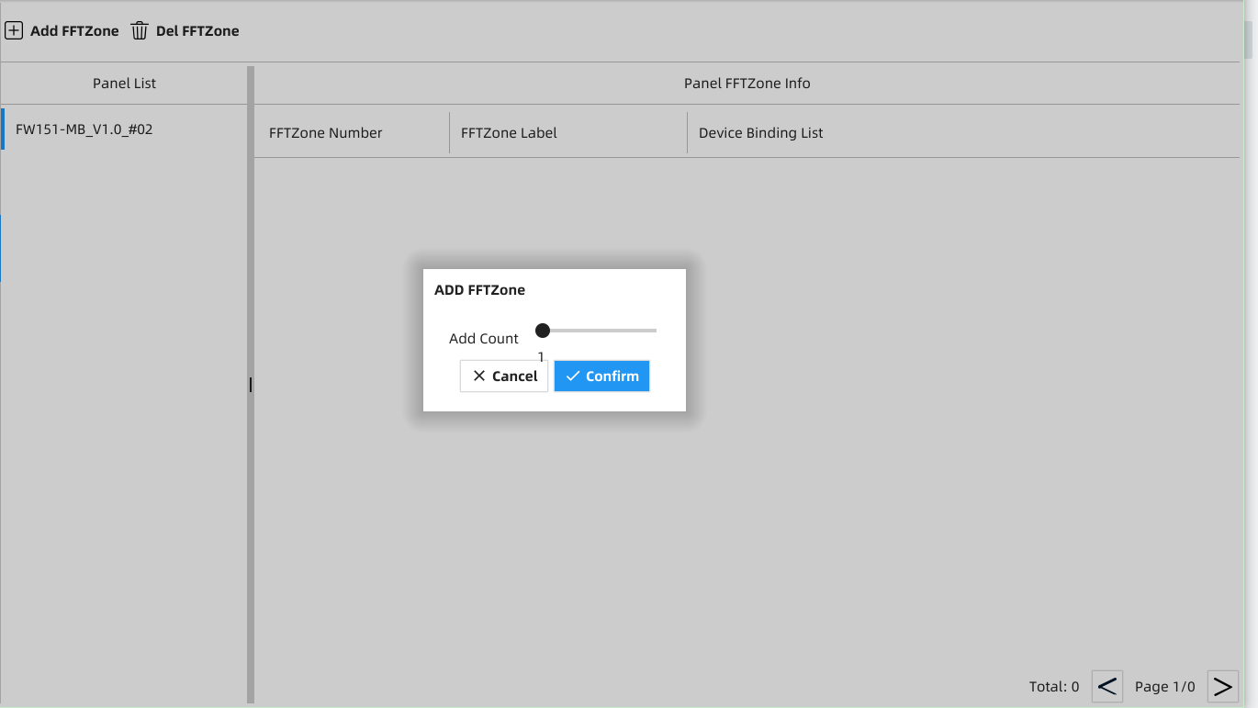
Figure EDCS19
Click Add FFT Zone on the menu bar and select the number of FFT Zones to be added.

6.4.2 Delete FFT Zone
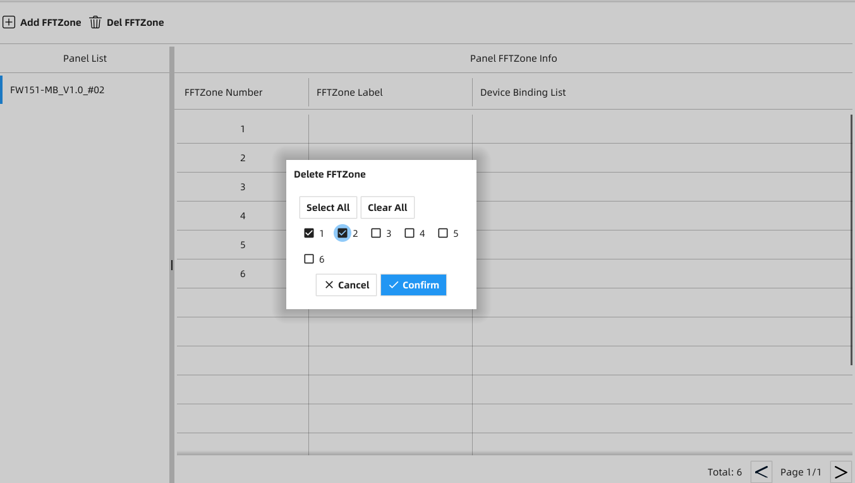
Figure EDCS20
Click Del FFT Zone and select the FFT zone number you want to delete.

6.4.3 FFT Zone Configuration
6.4.3.1 FFT Zone Number Setting
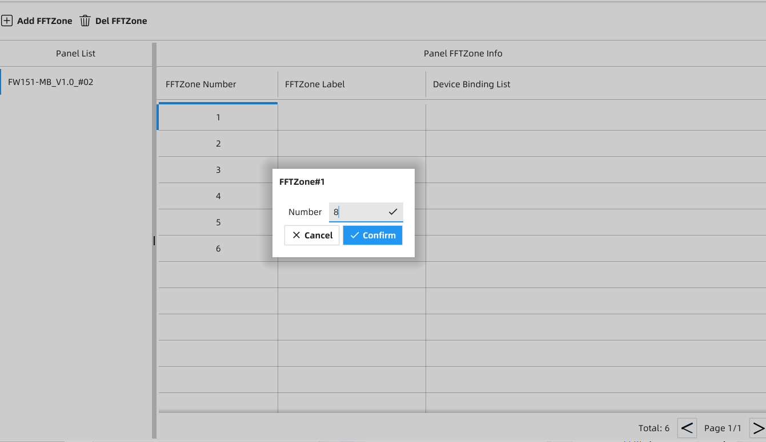
Figure EDCS21
a) Click FFT Zone Number and input the number in the pop-up window.

6.4.3.2 FFT Zone Label Setting
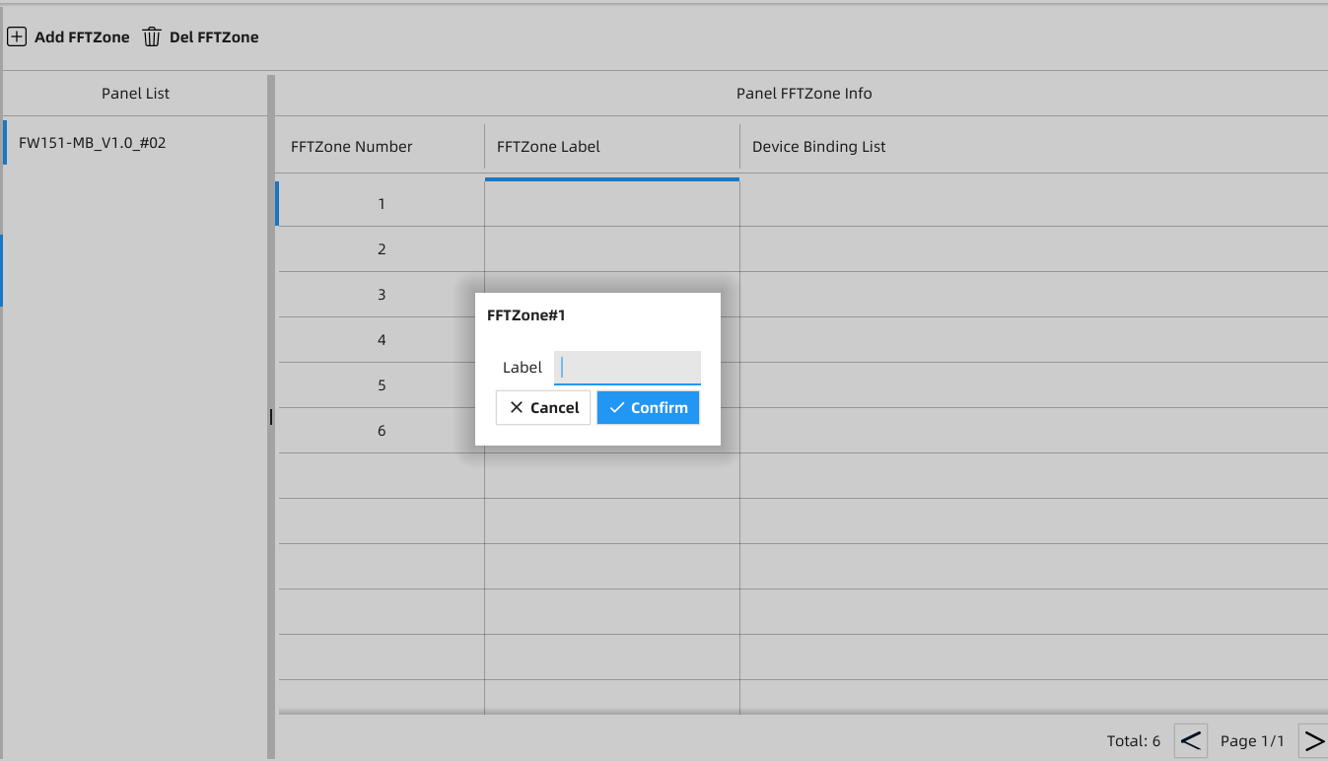
Figure EDCS22
a) Click FFT Zone Label to fill in the Label in the pop-up window.

6.4.3.3 FFT Zone Device Binding
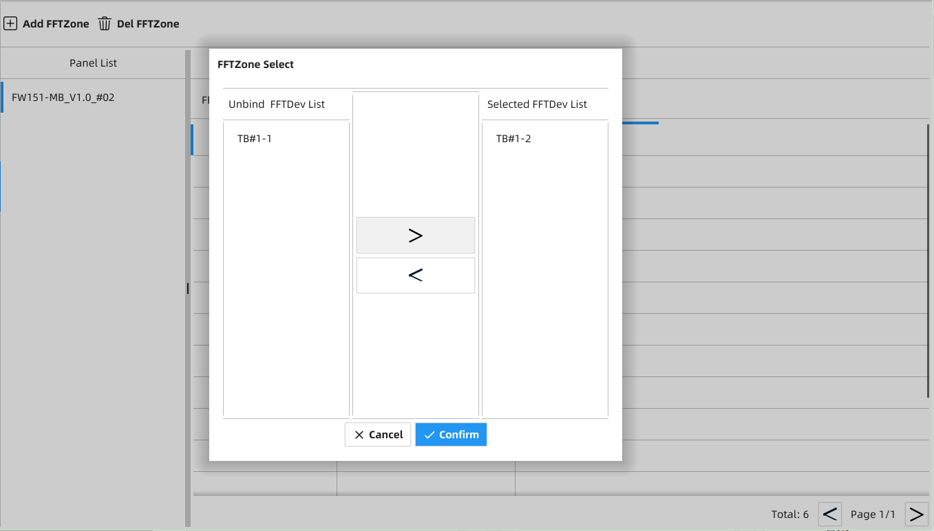
Figure EDCS23
a) Click Device Binding List and set up the device to be bound or unbound in the pop-up window.
＜: Unbind the selected TES
＞: Distribute the selected TES to the specific FFT Zone

6.5 Mapping Management
For mapping adding, deleting and configuration.

6.5.1 Mapping Adding
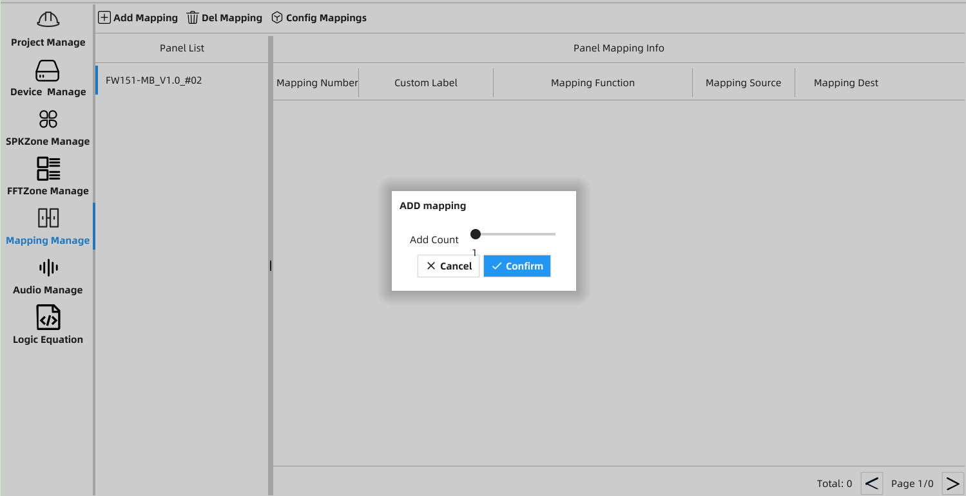
Figure EDCS24
Click Add Mapping and set up the number to be added in the pop-up window.

6.5.2 Delete Mapping
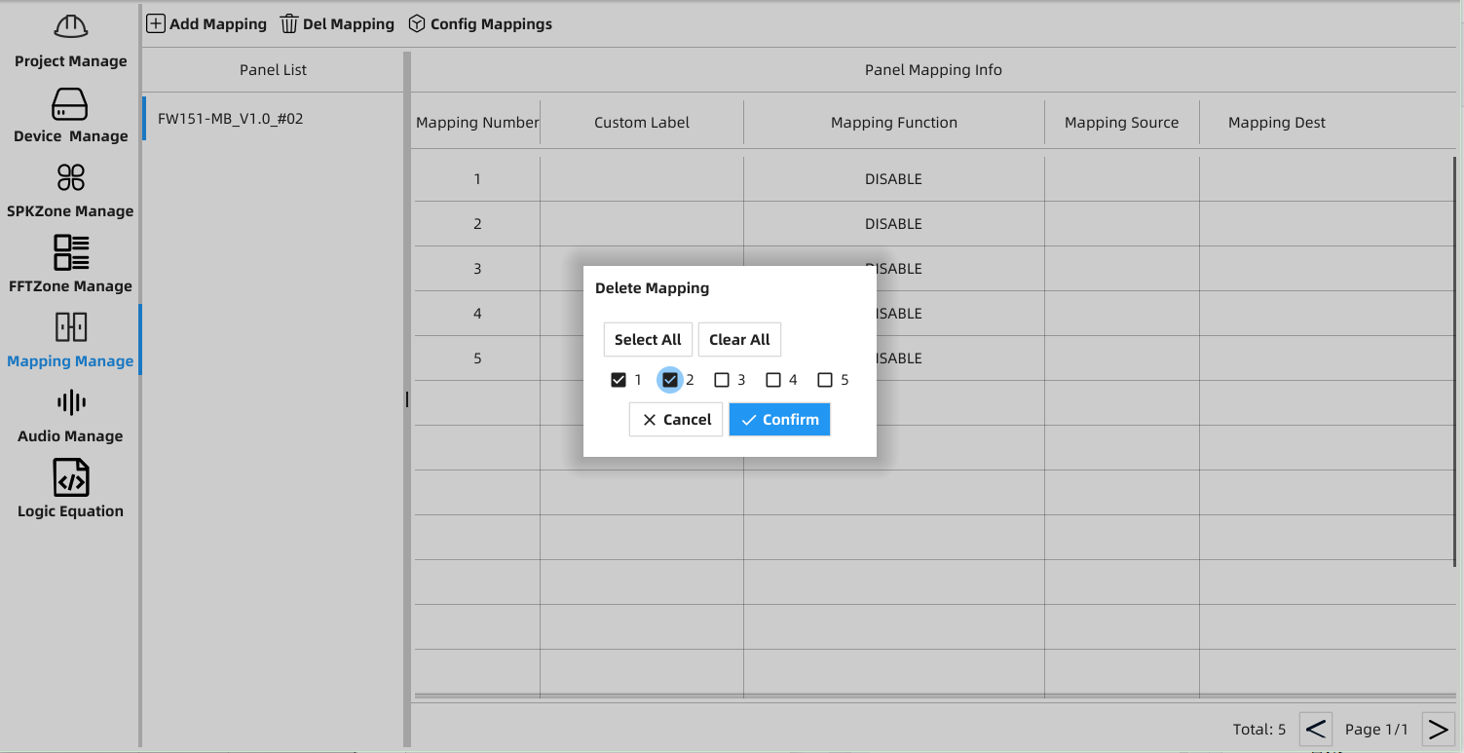
Figure EDCS25
Click Del Mapping and tick the mapping number to be deleted in the pop-up window.

6.5.3 Mapping Configuration
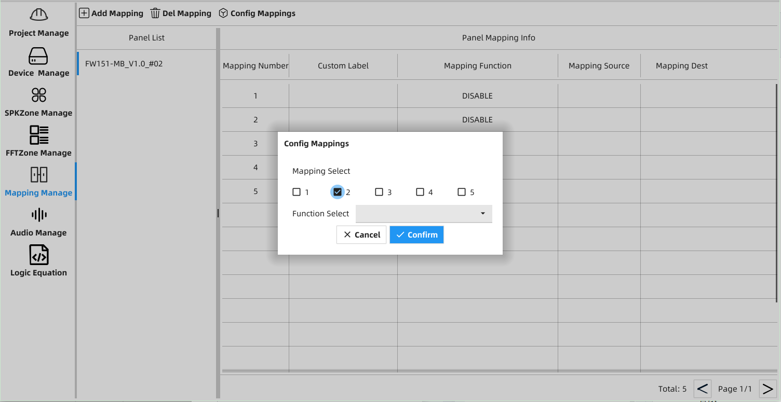
Figure EDCS26
Click Config Mappings and enter the required information as below in the pop-up window.
a) Check the required mapping number boxes
b) Select a function for the required mappings

6.5.4 Mapping Parameters Configuration
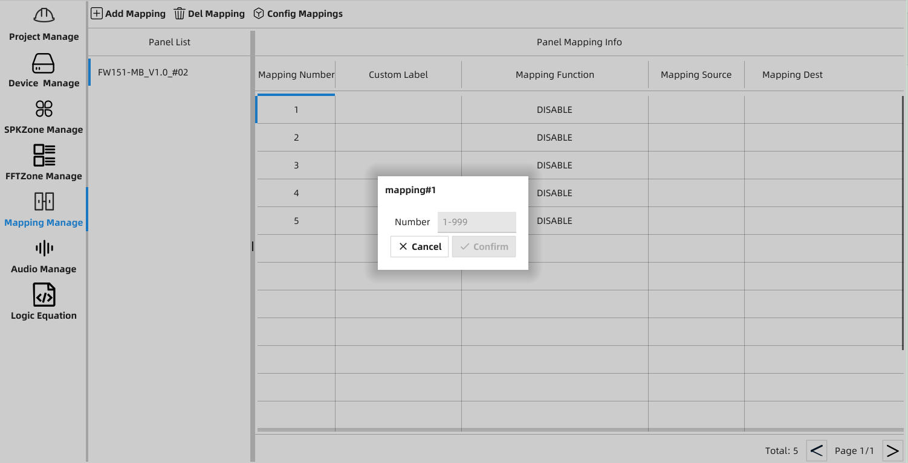
Figure EDCS27
a) Mapping Number Setting
Click Mapping Number and input the number in the pop-up window.
b) Custom Label Setting
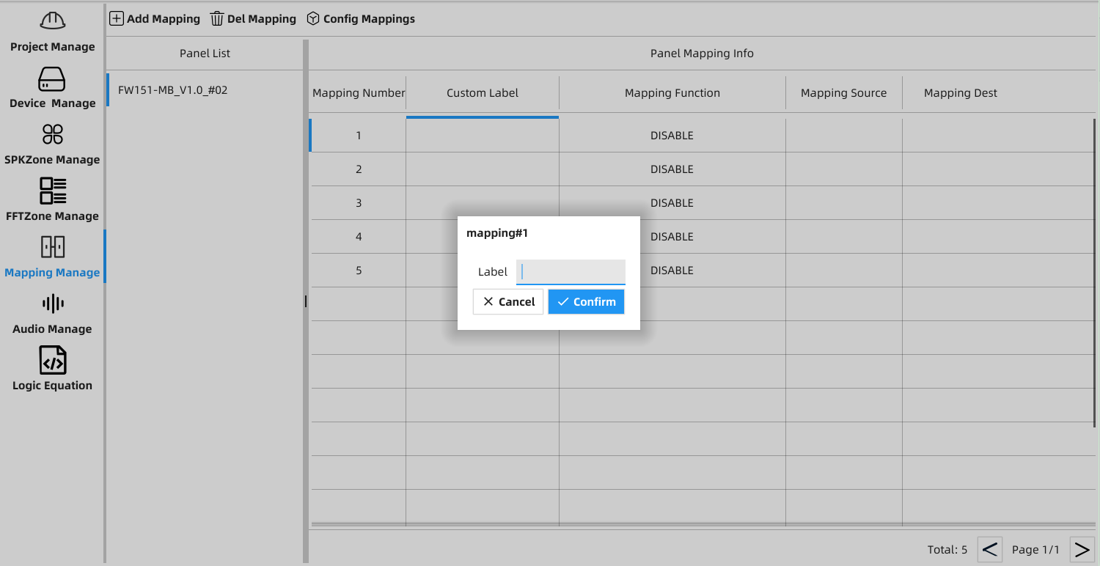
Figure EDCS28
Click Custom Label and fill in the Label field in the pop-up window.
c) Mapping Function
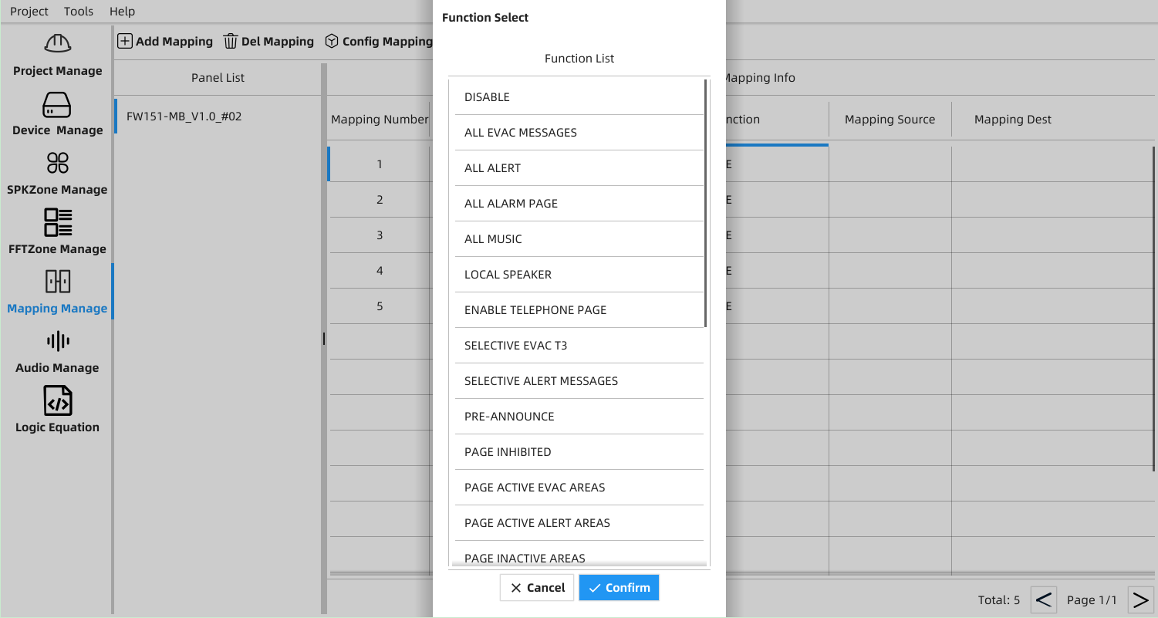
Figure EDCS29
Click Mapping Function and select a function from the Function List.
d) Mapping Source Selection
e) Mapping Dest Selection
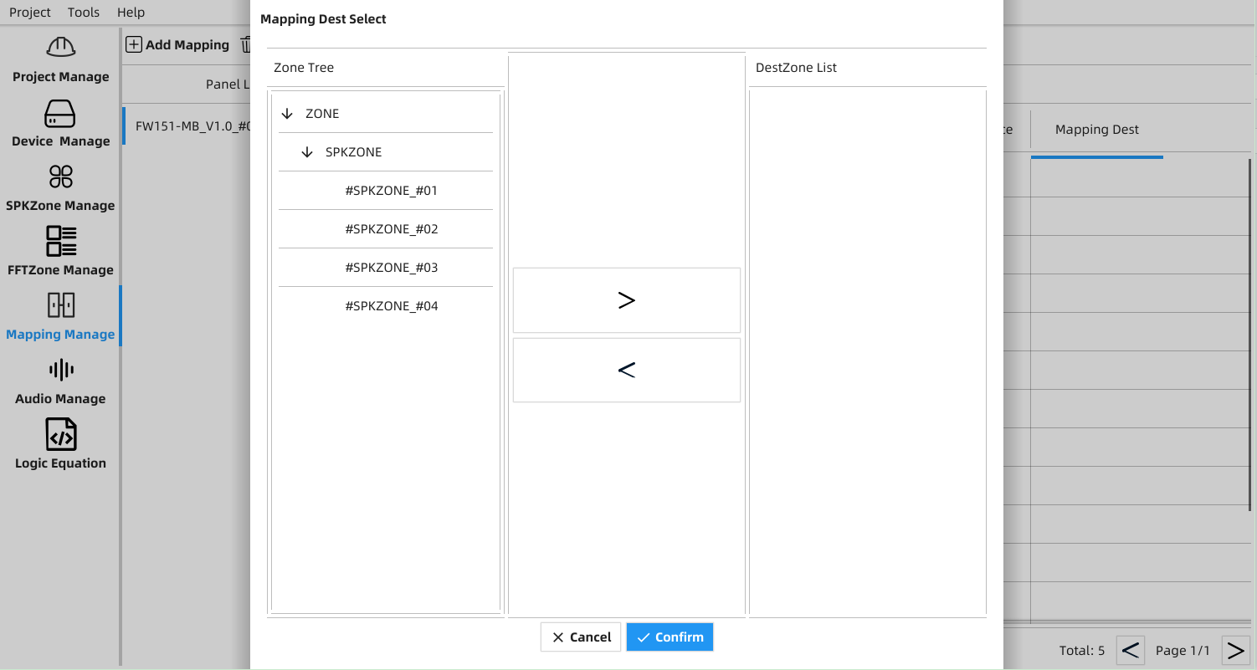
Figure EDCS30
＞: Selected FFT Zone or SPK Zone is mapped to Dest Zone List
＜: Unbind FFT Zone or SPK Zone from Dest Zone List

6.6 Quick Configuration

6.6.1 Project Configuration
a) Configured project file imported or configuration for new project
b) Following steps shall be completed for new project configuration:
- Create new project
- Device adding and device configuration
- FFT Zone adding and configuration
- Buttons mapping and configuration

6.6.2 Project Download
a) Select Project Manage section in the main screen of the EDCS Programming Tool
b) The controller is connected to the EDCS Programming Tool via the Ethernet RJ45 port, while the Download status indicator turns green
c) Select the project to be downloaded under Project Manage interface and click Download for a request from the controller
d) A download success confirmation is shown up in the pop-up window

7. Appendix-A: Compatible Devices

7.1 FFT Devices
Model No. | Description
FW863 | TES/Telephone Extension Station (addressable)
FW451-S | THS/Handset in Telephone Extension Station (connect to the station)
FW864A | TWJ/Telephone Wall Jack (addressable)
FW864 | TWC/ Telephone Wall Jack Conventional (non-addressable)
FW451-W | THW/ Fire Fighter’s Telephone Handset (connect to the wall jack)

8. Appendix-B: Wire Selection Guide

8.1 FFT Bus Wire Selection Guide
Maximum FFT BUS Current:
201mA (Idle), 304mA (5 Talking), Maximum FFT BUS Capacitance = 0.3uF
Table 19 Addressable FFT BUS Wiring
Wire Gauge |  |  | Maximum Wiring Run to the Furthest Fire Phone (EOLR)
(AWG) | Wire Size  Diameter(mm)  Sectional Area (mm²) | Two Wires Resistance  （ohms/km） | Maximum wire length
(AWG) | Wire Size  Diameter(mm)  Sectional Area (mm²) | Two Wires Resistance  （ohms/km） | ft | m
16 | φ1.29mm/1.318mm² | 13.5*2=27.00Ω | 5201 | 1585
18 | φ1.02mm/0.8107mm² | 21.4*2=42.8Ω | 3281 | 1000

9. Appendix-C: FW151-FP Power Consumption Calculations
Table 20 lists the maximum number of PCBA per FW151-FP.
Table 20 Maximum Number of PCBA
Module/Device | Description | Maximum Number per FW151
ZS | Zone Selector | 2
TES/TWJ | Telephone extension station/Telephone wall jack | 40
TWC | Telephone wall jack (conventional) | 160 (max. 4 with each TWJ)

10. Appendix-D: Battery Calculations

10.1 Total System Current Calculations
Table 21 System Current Calculation
IMPORTANT NOTICE
The main AC branch circuit connection for FW151-FP must provide a dedicated continuous AC power without provision of any disconnect means. Use #12 AWG wire with 600-volt insulation and proper over-current circuit protection that complies with the local codes. Refer to the Specifications and Features section.
FW151 Functional Modules’ Current (all current in ampere)
Module | Description | Qty. | Single  Standby | Total  Standby | Single  Alarm | Total  Alarm
FW151-FP | Minimum configuration  (including PS, MB, DB, DK, LCD, 1x ZS) | 1 | 0.271A |  | 0.273A
ZS (additional) | Zone Selector (max. 1) |  | 0.014A |  | 0.016A
TB | Telephone Board (max. 1) |  | 0.139A |  | 0.139A
Total |  |  |  | A |  | A
FFT Bus Current (all current in ampere)
For each BUS, the total quantities of addressable devices must not be more than 40, and that of non-addressable devices shall be 160 at most. The maximum total current of field telephones per addressable phones circuit is 175mA (standby), and 235mA (talking). The number of remote telephone for simultaneous talking is limited to 5 units that should be considered when calculating the total power of battery sets.
Device | Description | Qty. | Single  Standby | Total  Standby | Single  Talking | Total  Talking
TES | Telephone Extension Station(addressable)  (TES + TWJ: max. 40) |  | 0.00312A |  | 0.0265A
TWJ | Telephone Wall Jack (addressable)  (TES + TWJ: max. 40) |  | 0.00334A |  | 0.0239A
TWC | Telephone Wall Jack Conventional  (non-addressable)  (max. 4 connecting to each TWJ) |  | 0.00007A |  | 0.0212A
3.9K resistance | FFT BUS EOLR |  | 0.007A |  | 0.007A
22K  resistance | FFT BRANCH EOLR |  | 0.00123A |  | 0.00123A
Total |  |  | A |  | A

10.2 Battery Capacity
Table 22 Battery Calculation
Total Standby Current  (from above) | Hours of Standby Required per UL864 Standard |  | AH for Standby
A | x 24 Hours |  | = Ah
Total Alarm Current  (from above) |  | 15 Minutes of Alarm Operation per UL864 Standard,  5 Minutes of Alert for Two-stage, plus 2 Hours of Alarm Operation per ULC-S527 |  | AH for Alarm
A |  | x 0.25 Hours (For UL compliance) |  | = Ah
A |  | x 2.08 Hours (For ULC compliance) |  | = Ah
Total (standby + Alarm) |  |  |  | = Ah

Calculated total A.H. | De-rating  Factor | A.H. Required Battery Capacity
Ah | X 1.25 | = Ah
Maximum available two batteries space: L460mm x W168mm x H210mm (L18.11in. x W6.61in. x H8.28in.)
The maximum capacity of 24V battery sets is 20Ah.

Notes: Use of alternative batteries may result in failure of the panel that cannot meet agency and regulatory requirements and may shorten battery life. Batteries should be tested regularly and replaced at least every four years. If the Battery Trouble indicator is activated, the required service should be performed by an authorized agent.

11. Appendix-E: Glossary and Acronyms
- BATT ---- Battery Sets
- TBS -------- Telephone Board Slot
- DB--------- Daughter Board
- DCD ------ Digital Voice Control Distributor
- DCP ------ Fire Telephone System
- DK -------- Display and Keypad
- DRC ------ Digital Voice Remote Console
- EDCS ---- Emergency Digital Communication System
- FFT ------ Fire Fighter Telephone
- FFTB ---- Fire Fighter Telephone Bus
- MAP ------ Master Audio Panel
- MB -------- Master Board/Mother Board
- PS -------- Power Supply
- TB -------- Telephone Board
- TBL ------ Telephone Bus Line
- TES ------ Telephone Extension Station (addressable)
- THP ------ Handset in DCP (connect to the panel)
- THS ------ Handset in Telephone Extension Station (connect to the station)
- THW ----- Fire Fighter’s Telephone Handset (connect to the wall jack)
- TWC ----- Telephone Wall Jack Conventional (non-addressable)
- TWJ ------ Telephone Wall Jack (addressable)
Model | Module/Device | Details | Remarks
FW151-FP | DCP | Fire Telephone System
FW151-DB | DB | Daughter Board mounted on Mother Board
FW151-MB | MB | Mother Board mounted under Daughter Board
FW151-DK | DK | Display and Keypad
FW151-ZS | ZS | Zone Selector
FW151-TB | TB | Master Telephone Board for fire fighter telephone circuit
FW151-TBS | TBS | All PCBA's Board Slot
FW151-PS | PS | Power Supply
FW451-P | THP | Handset in DCP (connect to the panel)
FW863 | TES | Telephone Extension Station (addressable)
FW451-S | THS | Handset in Telephone Extension Station (connect to the station)
FW864A | TWJ | Telephone Wall Jack (addressable)
FW864 | TWC | Telephone Wall Jack Conventional (non-addressable)
FW451-W | THW | Fire Fighter’s Telephone Handset (connect to the wall jack)
FW2423-22K | EOLR | End-Of-Line-Resistor 22KΩ/2W
FW2423-3.9K | EOLR | End-Of-Line-Resistor 3.9KΩ/2W
- ZS -------- Zone Selector

Emergency Digital Communication System (EDCS) contains the following modules and devices.
- Class A Circuit(DCLA): A notification appliance circuit within which all components remain fully functional in case of a single open or a ground circuit.
- Class B Circuit(DCLB): A notification appliance circuit within which some or all components may be disabled with a single open or a ground circuit.
- CPU: Central Processing Unit.
- Enable/Disable: Refers to the state of individual circuits (inputs and outputs) or logic functions, regardless of the presence of their corresponding modules.
- End Of Line Resistor (EOLR): A device used to terminate a supervised circuit.
- Ground Fault: A trouble condition in which a low resistance has been detected between the system wiring and the electrical ground reference of the building.
- Labeled: Equipment or materials to which is attached a label, a symbol, or another identifying mark of an organization acceptable to the authority having jurisdiction and concerned with product evaluation, which maintains the periodic inspection of the production of such labeled equipment or materials. And by this labeling the manufacturer indicates compliance with appropriate standards or performance in a specified manner.
- LED: Light Emitting Diode.
- LCD: Liquid Crystal Display.
- Listed: Equipment or materials included in a list published by an organization acceptable to the authority having jurisdiction and concerned with product evaluation that maintains the periodic inspection of the production of the listed equipment or materials, and whose listing states either that the equipment or material meets the appropriate standards or has been tested and found suitable for use in a specified manner.
- NEC: National Electrical Code, also published as NFPA standard 70.
- Notification Appliance: An electrically operated appliance used to notify building’s occupants of any emergency condition in the building (fire alarm, bomb threat, etc.), such as a bell, horn, strobe light, or speaker.
- Power Supply: The part of the Fire Telephone System which provides the power needed to operate all control panel modules and all notification appliances.
- Programming Tool: Refers to an external proprietary software package that allows the user to program the Fire Alarm Control panel.

- Reset Condition: A condition in which the panel is forced to return to its normal state, usually performed by pressing the “SYSTEM RESET” button after all known events/conditions are cleared.
- Supervisory: A signal indicating the operation of a supervisory device.
- Trouble Signal: An audible signal indicating trouble of any nature, such as an “open circuit” or a “ground fault” condition, occurring in the device or in the wiring associated with a fire alarm signal.
- Zone: A designated area of a building, commonly identified as a zone, is interchanged with an initiating device circuit.

Maple Armor

© 2023 MAPLE ARMOR FIRE ALARM DEVICE CO., LTD.
8866, boulevard du Quartier, Brossard, Quebec, Canada, J4Y 0R2

Data and design subject to change without notice.
All rights reserved.
www.maplearmor.com

